./

GENESIS - Learning Outcome & Mini-project Summary Report



|  |  |  |  |  |  |
| --- | --- | --- | --- | --- | --- |
| **Ver. Rel. No.** | **Release Date** | **Prepared. By** | **Reviewed By** | **To be Approved** | **Remarks/Revision Details** |
| 1. |  | Abhishek Guria/  99003726 |  |  |  |
|  |  |  |  |  |  |
|  |  |  |  |  |  |
|  |  |  |  |  |  |
|  |  |  |  |  |  |

**Details**

Contents

Contents 3

APPLIED SDLC CALCULATOR 7

INTRODUCTION 7

MY PRODUCT: “SEMI-ENGINEERING CALCULATOR” 7

RESEARCH 7

SWOT ANALYSIS: 8

REQUIREMENTS: 8

LOW LEVEL REQUIREMENTS: 10

**References** 12

DESIGN 12

HIGH LEVEL DESIGN 12

LOW LEVEL DESIGN 13

INBUILT CONSTANTS AND THEIR OPERATIONS:- 14

BEHAVIOURAL DIAGRAMS:- 15

**TEST PLAN** 16

Implementation Summary 17

Git Link 17

Git Dashboard 17

Unit Testing 17

Test plan for power of given function:- 17

Test plan for Trigonometric functions:- 19

Individual Contribution & Highlights:- 20

Challenges Faced And How Were They Overcome:- 22

LEARNING REPORT-C-PROGRAMING :- 23

Introduction To C Programming 23

Commands:- 23

Programming for beginners: 24

STEPS FOR COMPILING AND RUNNING A C PROGRAM: 24

WRITING COMPILING AND EXECUTION OF A C PROGRAM 24

BASIC STRUCTURE OF A PROGRAM 25

Section Description 25

Learning Certificate on SOLOLEARN: 26

ACTIVITY 2 28

C-PROGRAMS 28

Link: 30

EMBEDDED C : HARDWARE + PROGRAMMING + TESTING 31

INTRODUCTION TO THE SOFTWARE : STM32CUBEIDE 31

Activity 1 – COMPILATION APROACH 33

1.2- STARTUP CODE 36

1.3- LINKER SCRIPT 38

1.4- DEBUGGING TECHNIQUES 39

Activity 2 – IMPLEMENTATION OF PROTOCOLS USING STM IDE 41

2.1 GPIO: 41

2.2 EXTI: 42

2.3 ADC 45

2.4 SPI 46

2.5 UART 50

Advanced Python Programming Summary Report 57

PROBLEM STATEMENT:- 57

Defining the idea for project : 57

Detailed Requirements:- 58

Swoat Analysis:- 59

4 WH1’S :- 59

DESIGN:- 60

Structral Diagram 60

Behavioral Diagram 61

SOURCE CODE:- 61

Code Quality:- 65

GITHUB LINK: 65

Learning Certificates:- 66

Refrences:- 67

Learning Report – Embedded Linux & Kernel Device Drivers Programming 68

INTRODUCTION OF EMBEDDED LINUX 68

1.2 Size 68

1.3 Time constraints 68

**1.4 Concept of Embedded LINUX** 68

**1.5 LINUX Bootloaders:** 69

QEMU BASED EMULATION 70

**2.1 Introduction about QEMU** 70

**2.2 Operating Modes of QEMU:** 70

• QEMU has multiple operating modes 70

**3.1 Toolchain:** 71

**3.2 Toolchain components:** 72

3.2.1 Binutil: 72

3.2.2 C library 72

3.2.3 Debugger 72

**3.3 Installation of Toolchain:** 72

4. EMULATION AND SIMULATION 72

**4.1 First Boot (Emulation):** 73

**4.2 First Steps on Target:** 73

5. BUILDING CUSTOM KERNEL (QEMU): 73

**5.1 Download Kernel Source:** 73

**5.2 Obtain Configuration File:** 73

**5.3 Customization:** 74

**5.4 How to build the Kernel:** 74

**5.5 How to test the Built outcome:** 74

6. CROSS COMPILING CODE 75

**6.1 Simple Hello Module:** 75

**6.2 Multi file Programming:** 75

**6.3 Static Library:** 76

**6.4 Dynamic Linking:** 76

7. WORKING WITH U-BOOT 76

**7.1 Cross Building:** 76

**7.2 Simple Boot – Rootfs in SD Card:** 77

**7.3 Prepare Partitioned in SD Card:** 77

**7.4 Rootfs in Partitioned SD Card:** 78

**7.5 Setup TFTP on Host:** 78

**7. 4.** **Booting kernel using Networking:** 79

**7.5 Setup TFTP on host:** 79

8. DEVICE TREE 80

**8.1 Introduction of Device Tree** 80

**8.2 High Level View about Device Tree** 80

8.2.1 Platform Identification: 80

8.2.2 Runtime configuration 80

8.2.3 Device population 81

**8.3 Booting With Device Tree** 81

**8.4 Compatibility mode for DT booting** 81

9. WHAT DO YOU MEAN BY KERNEL? 81

**10.1** **There are three types of kernels:** 82

10.1.1 A monolithic kernel 82

10. WHAT DO YOU MEAN BY MODULES? 82

14. BUILDINF KERNEL MODULES 83

**14.1 Simple Hello Module:** 83

**14.2 Simple hello Module with init and exit function** 84

**14.3** **Hello module with parameters** 84

**14.4 Module Dependency simple** 84

**14.5 Module Dependency sample** 85

**14.6 ADDING KCONFIG ENTRIES** 85

**14.7 Version 2 for K Config entries:** 85

15 WHAT DO YOU MEAN BY SYSTEM CALLS? 86

**15.1 Services Provided by System Calls :** 86

**15.2 Adding a system call:** 86

16 PSEUDO CHAR DRIVER 87

**16.1 Statistically registration device driver** 87

❖ int register_chrdev_region(dev_t first, unsigned int count, char *name) 87

**16.2 Dynamically registration of Character Device Driver** 87

**16.3 Un-registration of character device driver** 88

**16.4 Device file Creation:** 89

18. KERNEL DATA STRUCTURE 90

**18.1** **Kfifo API:** 90

19 IPC IN KERNEL 91

**19.1 Semaphors:** 91

**19.2 Semaphore API** 91

**19.3 Mutex:** 92

**19.3 Spin Locks:** 92

**19.4 Reader-writer spinlocks:** 92

**19.5 Wait Queue API:** 92

**19.6 Generate Race Conditions in Pseudo Driver:** 93

20. IOCTL USAGE 93

21. References: 93

Module/s 94

Topic and Subtopics 94

Objectives & Requirements 94

Design 94

Test Plan 94

Implementation Summary 94

Git Link 94

Git Dashboardbgfjythfjk 94

Summary 94

Cdmslvf;ldvl 94

cfgdgdgfc 94

Individual Contribution & Highlights 95

Summary 95

Challenges faced and how were they overcome 95

# APPLIED SDLC CALCULATOR

**SYSTEM/ SOFTWARE DEVELOPMENT**

## INTRODUCTION

We have attempted to build the software development cycle of a semi-engineering calculator. It includes the numerous high-level and low-level requirements of the various features involved in semi-engineering such as log, antilog, exponents roots and polynomial functions. It then explores about the various test cases that should be taken in consideration such that all requirements are taken care of. In the end, we build the codes that follow all the requirements and design efficiently as per them.

## MY PRODUCT: “SEMI-ENGINEERING CALCULATOR”

Our system is more or less semi advanced which basically able to do desirable calculations of daily basis from bottom to top level i.e. it includes every basic operation which eats lots of time in scheduled timings.

## RESEARCH

There are different types of calculators with respect to the cost and its features. It is plotted in the graph shown below which shows the range of calculators for highest cost and lowest feature and vice versa. The range we have chosen is for a medium range cost and feature. It is similar to a programmable scientific calculator. It will be more efficient for the multipurpose use.

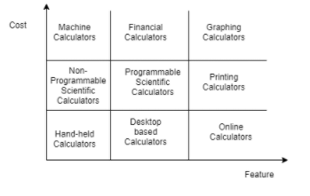

Figure1: Cost vs Features

## SWOT ANALYSIS:



Figure2: SWOT Analysis

## REQUIREMENTS:

The calculator build by us includes basic arithmetic functions, trigonometric functions and exponential functions. It also consists of some other functions including power, log, antilog, permutation and combination functions.

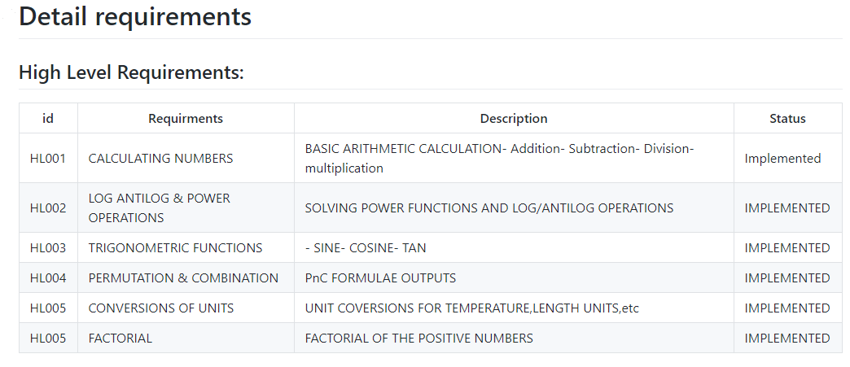

## LOW LEVEL REQUIREMENTS:

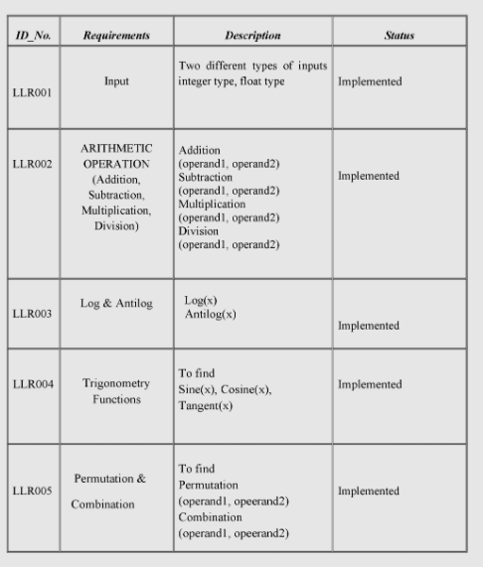

# ACTIVITY 2: AGILE METHODOLOGY

**Theme-Calculator**

The theme is designing a calculator with certain features according to the specific requirements.

The target customers for the calculator are school and college going students for semi-engineering and various other branches.

**Epic**

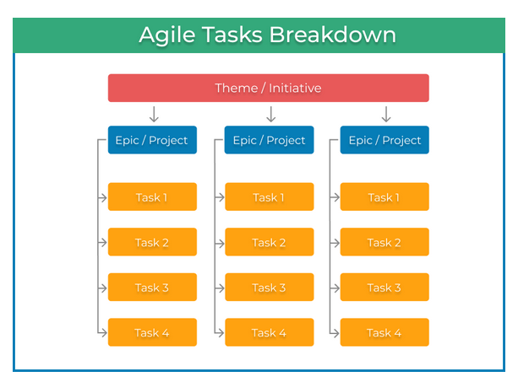

Epic according to the requirements provided are:

1. To find out power of particular value
2. Trigonometric Ratios.
3. Complex Functions(i.e log antilog, and constants).

**User Story**

## **References**

1. <https://kanbanize.com/agile/project-management/tasks-epics-initiatives-themes>
2. <https://geekbot.com/blog/epics-stories-themes-tasks/>
3. <https://www.atlassian.com/agile/project-management/epics-stories-themes>

# DESIGN

## HIGH LEVEL DESIGN

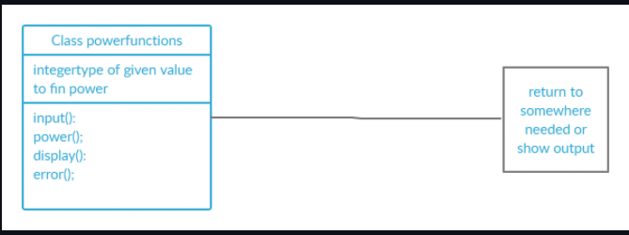

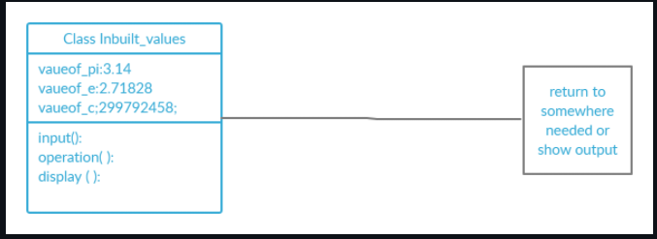

**Figure 1&2: High level Diagram**

## LOW LEVEL DESIGN

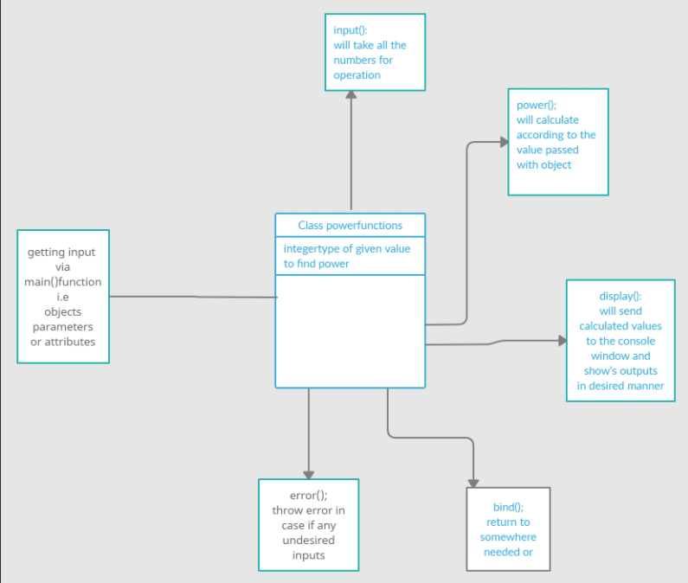

**Figure3: Component Diagram for**

# INBUILT CONSTANTS AND THEIR OPERATIONS:-

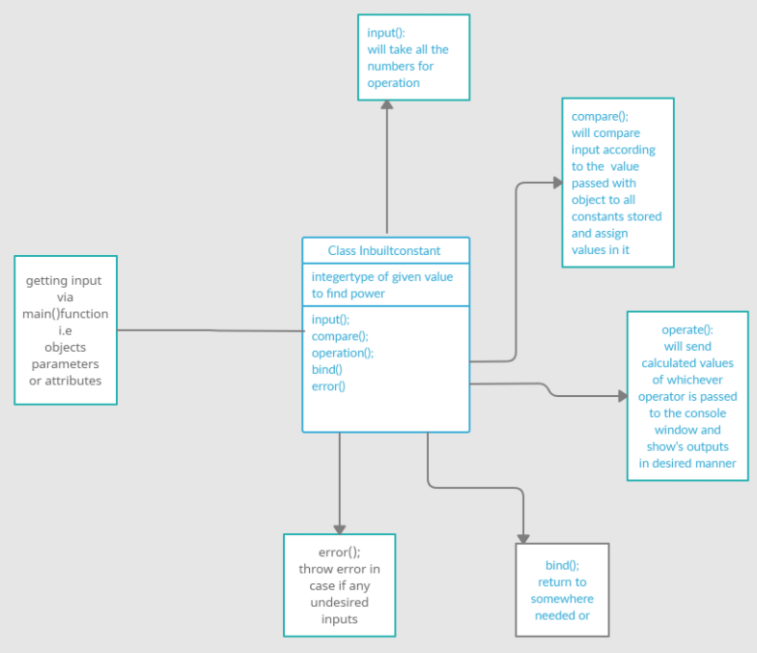

**Figure 4: Component Diagram for**

# BEHAVIOURAL DIAGRAMS:-

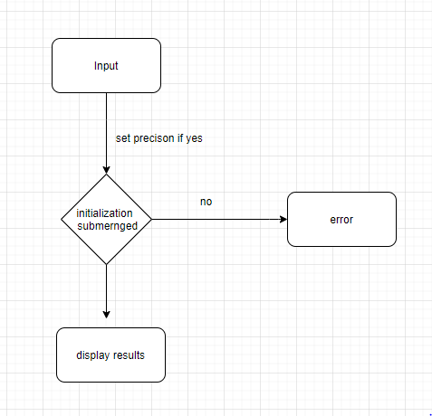

**Figure 3: For digit precision**

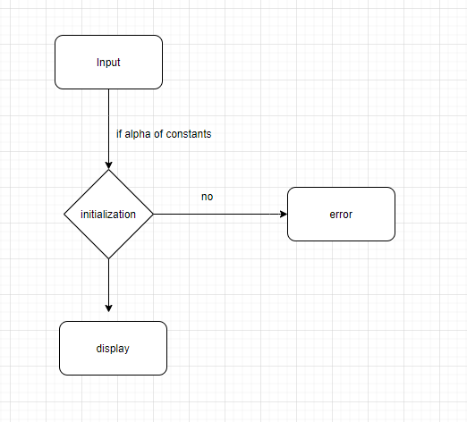

**Figure 4: Diagram for Constants**

## **TEST PLAN**

“Integration level and unit level in the template”

## Implementation Summary

“Section focused toward’ s implementation aspects. Here it is only core summary while all the details are in the Git Repo

Note: The GitHub private repo should be documented (Readme.md files at each folder level)

Ensure code quality and clean code and description practices

Mandatory: To add the GitHub user - **stepin654321** as a contributor to the repo”

### Git Link

<https://github.com/99003721/AppliedSDLC_Calculator_N1>

### Git Dashboard

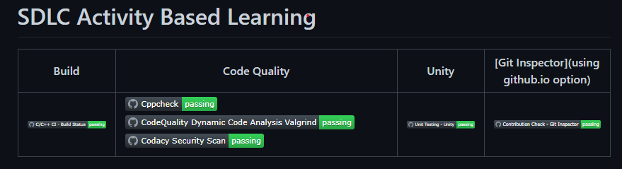

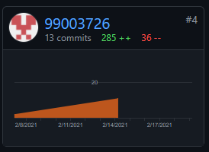

# Unit Testing

## Test plan for power of given function:-

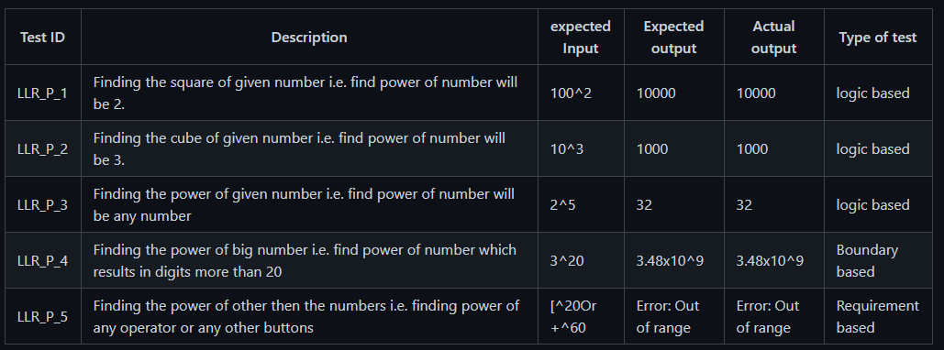

## Test plan for Trigonometric functions:-

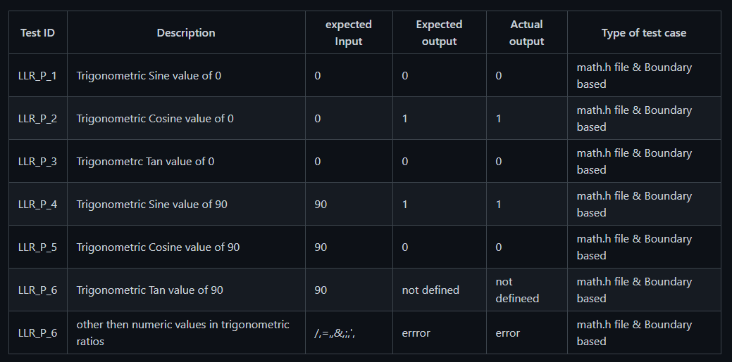

## Individual Contribution & Highlights:-

**Power functions:**

1. Find out the square & square root.
2. Find out the cube & cube root.
3. Answer in less than 8 digits
4. Less than 8-digit input

**Trigonometric Ratios:**

1. To find Sine
2. To find Cosine of given angle
3. To get tan value.

**Complex functions**:-

1. To find out the logarithmic values.
2. To find out the antilogarithmic values.
3. To use inbuilt constants and do operations on them.

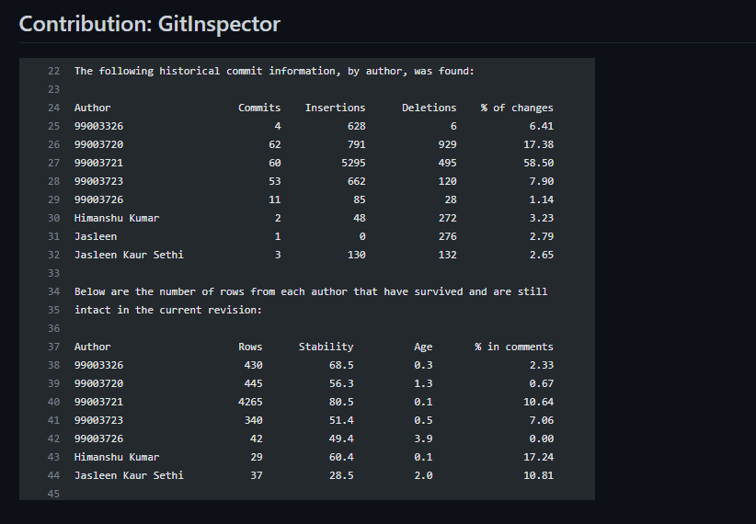

# Challenges Faced And How Were They Overcome:-

* Running the make file as its resolved by defining its correct path(.out for linux and -lm for math functions)
* Syncronizing the VS code to github , colleague help to resolve the issue
* Making the function call in correct path
* Open git log while committing, thus went to github desktop and pulled origin and then pushed origin.
* Test case code for the boundary problem. Added code with the help of internet

### 

# LEARNING REPORT-C-PROGRAMING :-

# Introduction To C Programming

C is a procedural programming language which was initially developed by Dennis Ritchie in the year 1972. The important characteristics of this language includes a clean style, low level access to memory, simple set of keywords, which makes this language very acceptable for programmers. Following is a list of commands and syntax used in c programming with explanation:

## Commands:-

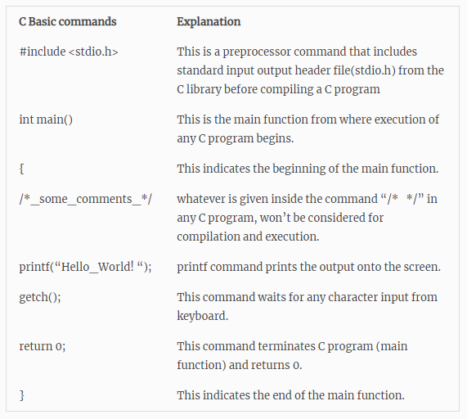

# Programming for beginners:

The Hello world program shown below displays “Hello World” in the output. Every program statement terminates with a semicolon (;) and so it is known as statement terminator. Also C program is a case sensitive language. So upper case and lower case affects the programming.

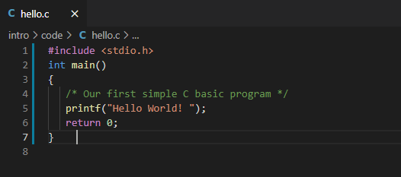

OUTPUT:

Hello World

## STEPS FOR COMPILING AND RUNNING A C PROGRAM:

**Following are the steps required to create and get the output of any C program. The steps are common to all the programming language with no exception. No matter whether the code is large or small.**

**Coding**

**Compiling**

**Executing and running**

**Generating the output**

## WRITING COMPILING AND EXECUTION OF A C PROGRAM

1. Prior Requirement: For creation, compilation and execution of C Program, it is necessary to have a compiler like gcc. For the course we used GCC compiler on platform called as Visual Studio code

# BASIC STRUCTURE OF A PROGRAM

All programs has different section or parts which has its own function. Each section is used by the programmer with a set of protocols which define the structure of C program.

Below are the set of Functions:

Main Function

Definition section

Function prototype declaration section

Documentation Section

Link Section

Global Declaration section

User defined function definition section

## Section Description

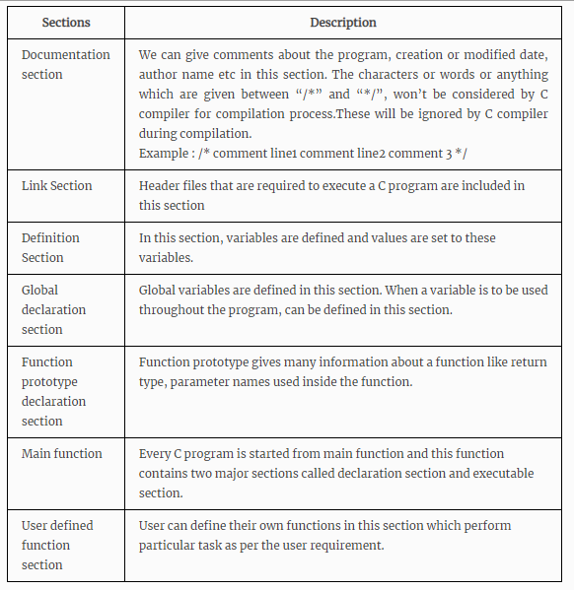

# Learning Certificate on SOLOLEARN:

Below is the certificate on sololearn:



**Figure 1: C Program Learning Certificate**

## ACTIVITY 2

## C-PROGRAMS

**Program 1:- Write a program to break the given string and return the correct string between ‘$’ and ‘;’**

**Ex 1: Input “Garbage$Welcome to LTTS;ignore”**

**Output: “&Welcome to LTTS;”**

**Ex2: Input “Hello$This is $$an example #2string;And filled with words”**

**Output: “$an example #2string;”**

**Code:**

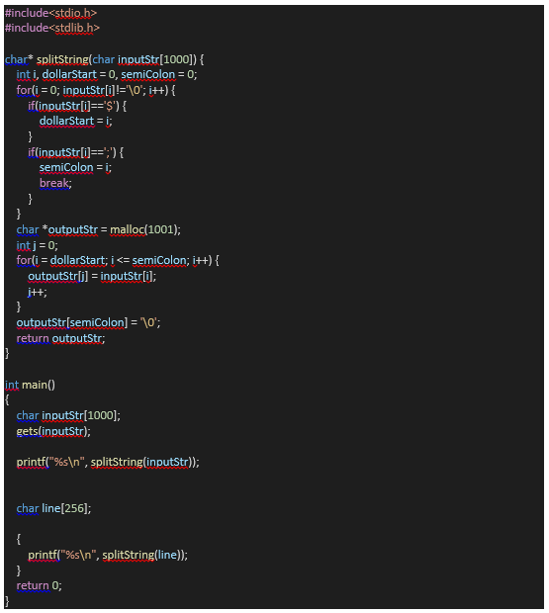

**Program 2: In program 1 pass the input string after reading from the file.**

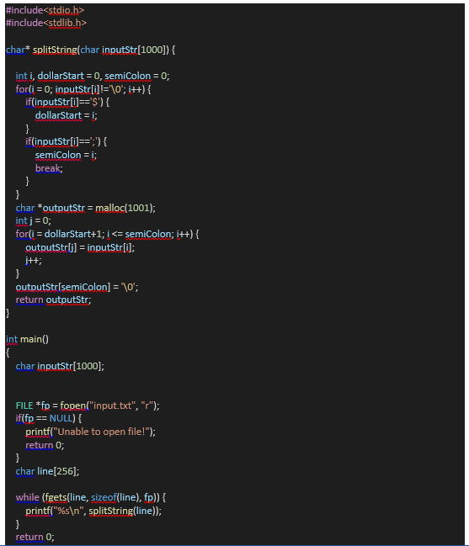

# GitHub :

## Link:

- <https://github.com/99003726/cprogram.git>

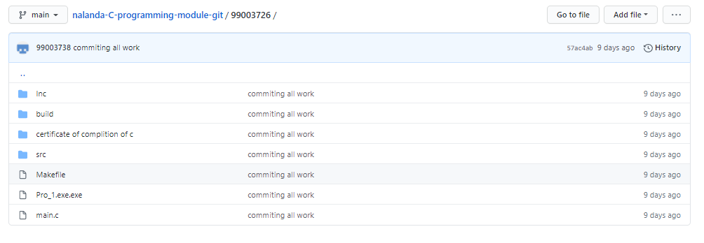

**Git Repository**

# EMBEDDED C : HARDWARE + PROGRAMMING + TESTING

# INTRODUCTION TO THE SOFTWARE : STM32CUBEIDE

* STM32CubeIDE is a multi-OS development tool, which is part of the STM32Cube system program.
* STM32CubeIDE is a state-of-the-art C / C ++ development platform with boundary modification, code production, code integration, and debugging features for STM32 microcontrollers and microprocessors. Based on the Eclipse® / CDT framework and the GCC development tools, as well as the GDB debugging. Allows integration of hundreds of existing plugins that complete the Eclipse® IDE features.
* STM32CubeIDE combines STM32 configuration and project creation functionality from STM32CubeMX to provide the same tools experience and save installation time and development time. After the selection of the STM32 MCU or blank MPU, or a customized microcontroller or microprocessor from the board selection or model selection, the project is created and a code is generated. At any time during development, the user can revert to implementation and configuration or middleware and update the startup code without affecting the user code.
* STM32CubeIDE includes build and layout analysts that provide the user with useful information about project status and memory requirements.
* STM32CubeIDE also includes advanced and advanced debugging features including basic CPU registers, memory, and road-related registers, as well as a flexible live clock, Serial Wire Viewer interface, or error analyzer.

**GETTING STARTED WITH THE SOFTWARE:**

Start the software:

1. Goto file 🡪 New🡪 STM32 Project

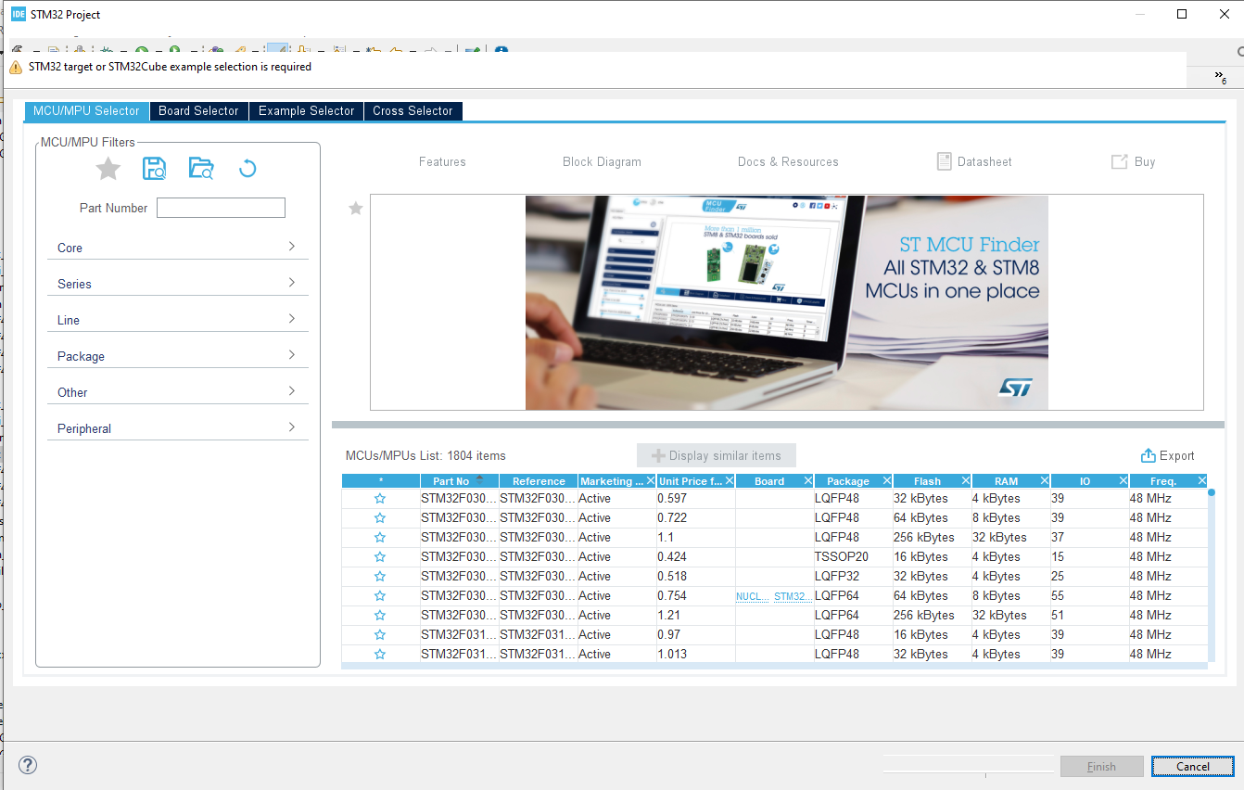

1. Select the board and star it for frequent uses and start with the project .

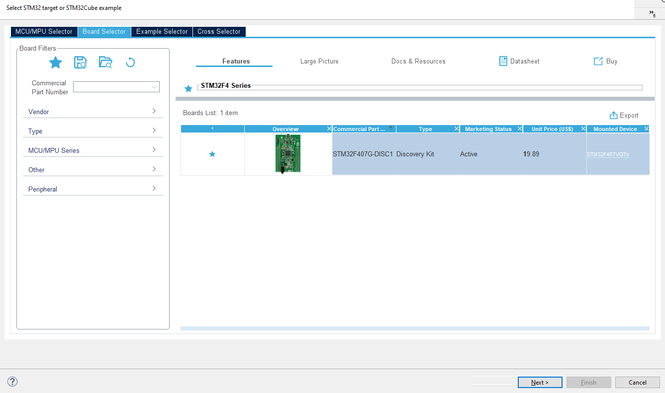

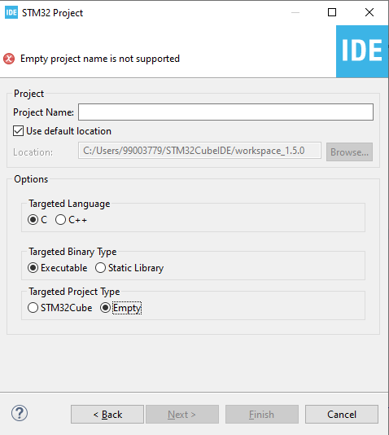

Type the name of the project and start with the coding.

# Activity 1 – COMPILATION APROACH

This is a complete process for integrating the ARM Cortex Mx processor sample system. The following are the integration stages of plan C:

1. Preprocessor stage
2. Compilation stage
3. Assembly stage
4. Linking stage

**1.1- MAKE FILE**

Below is the make file for the sample program:

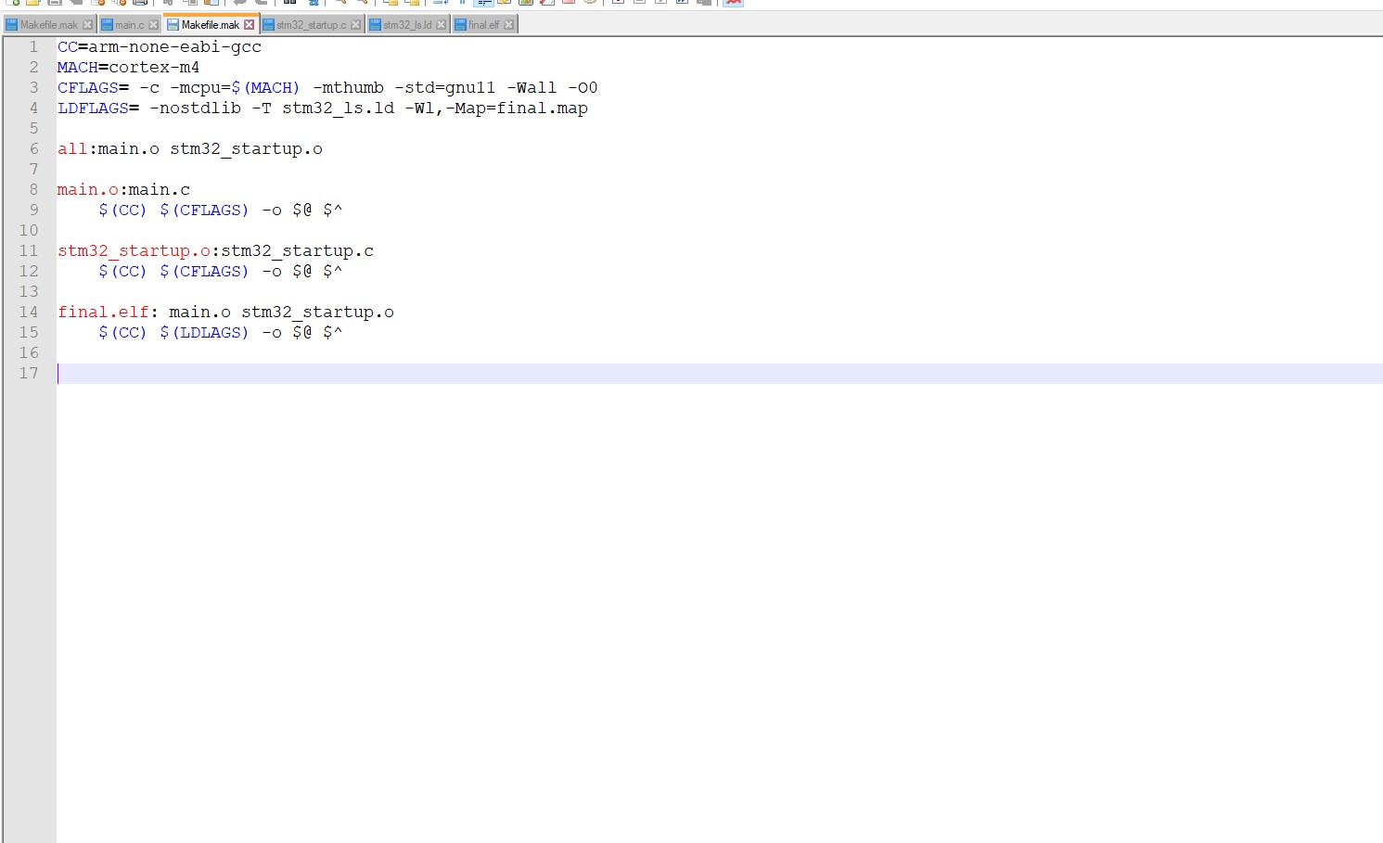

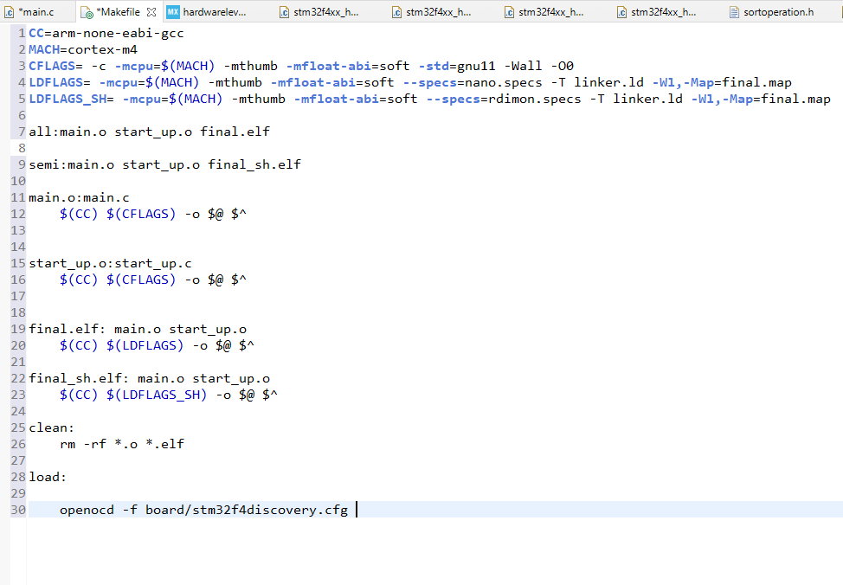

**Fig 1. Make file**

The command to run this make file in the command prompt is:

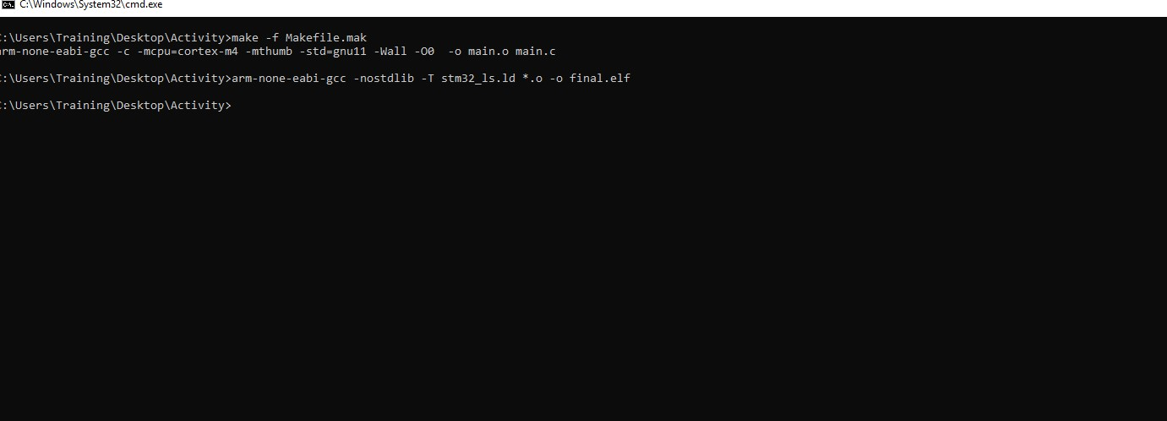

**Fig 2 Make command**

* -mcpu = cortex-m4 used to select our cortex-m4 processor used
* -mthumb is used to generate output code in ARM state
* main.o is a redirect file
* main.c dependence

## 1.2- STARTUP CODE

• The start up file is responsible for setting the correct code usage fields in the main.c file.

• Part of the start code depends on the direction (processed)

• Role of startup file:

1. Create a special MCU microcontroller vector table.

2. Write the startup code that starts the data section and .bss in SRAM.

3. Call the main ()

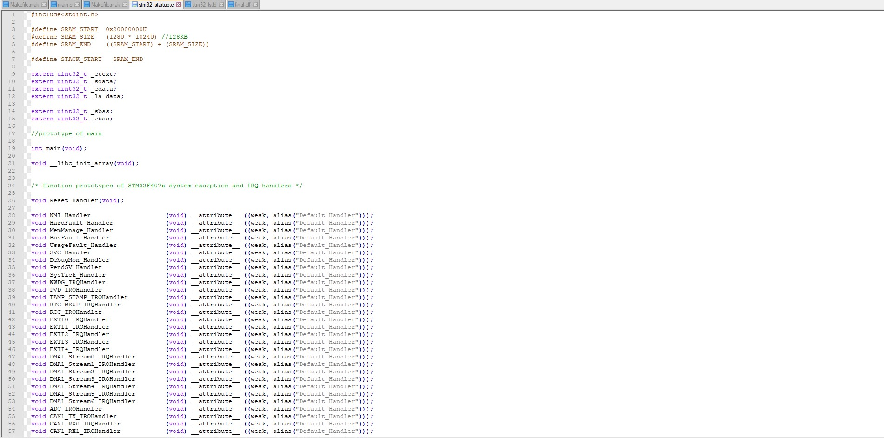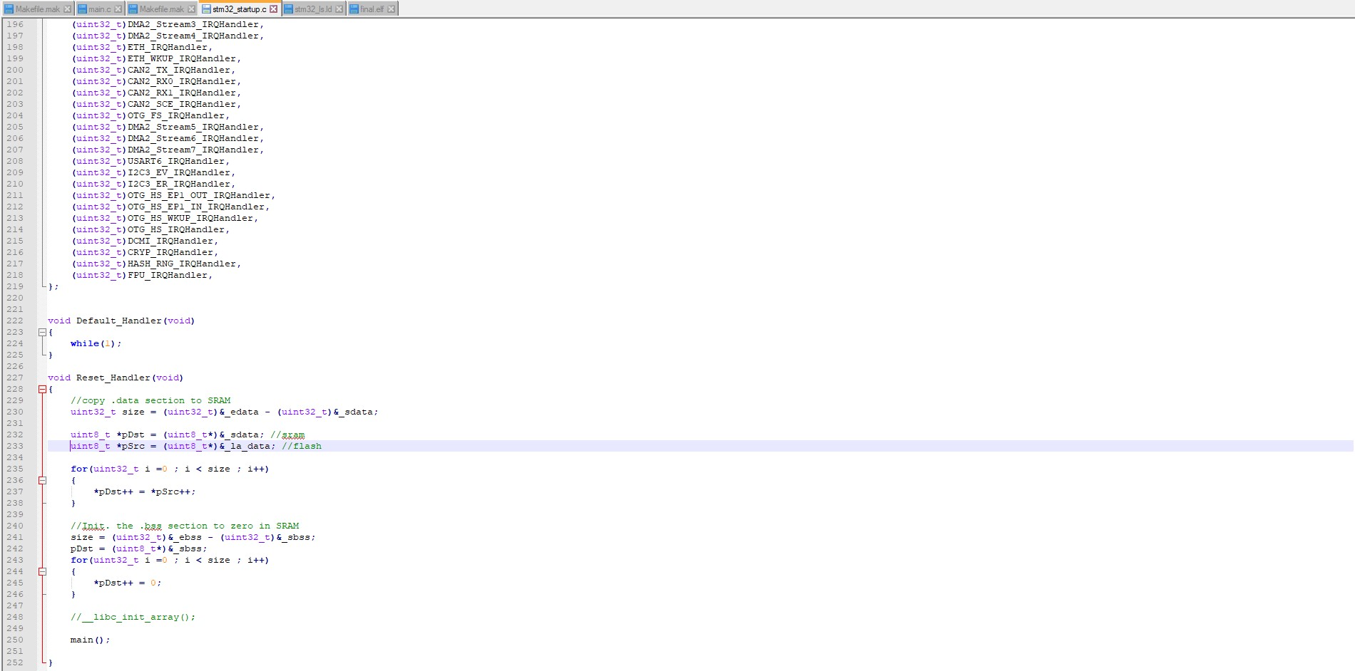

**Fig 3. Startup code**

In the startup code we use the attributes to keep the variable in the user-defined function.

Job qualifications:

• Weakness: Allows the app to override a previously defined weak function (dummy function) with the same function name.

• Alias: Lets programmer provides any alias name for the same function.

A startup.o file made in usable format, the various components of which are shown below:

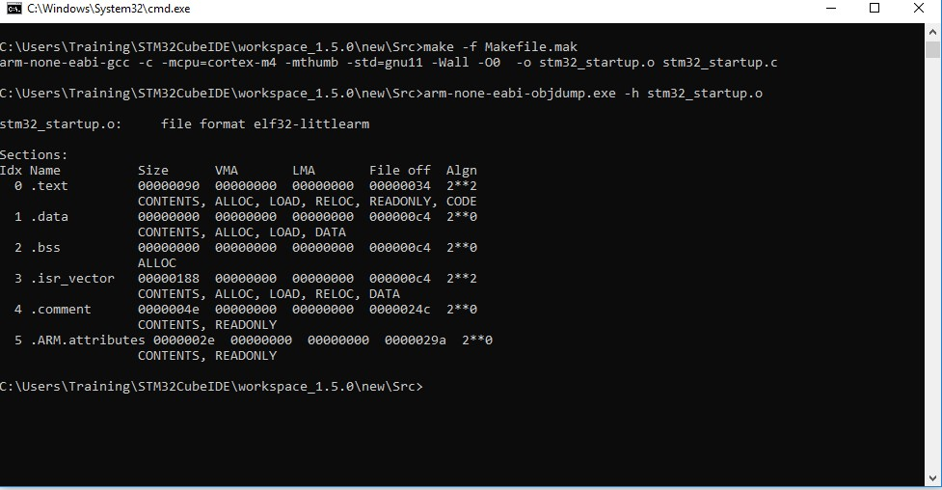

**Fig 4: Startup command**

## 1.3- LINKER SCRIPT

• Linkers take one or more object files or libraries as input and combine them to create a single usable file as output.

• Linker scripts determine how different categories of object files should be compiled to create an output file.

• Reset holder is the login of the application

• The login command is used to set the "login address address" information in the last elf file file created.

Syntax: Login (brand_sign)

Login (Reset_Manager)

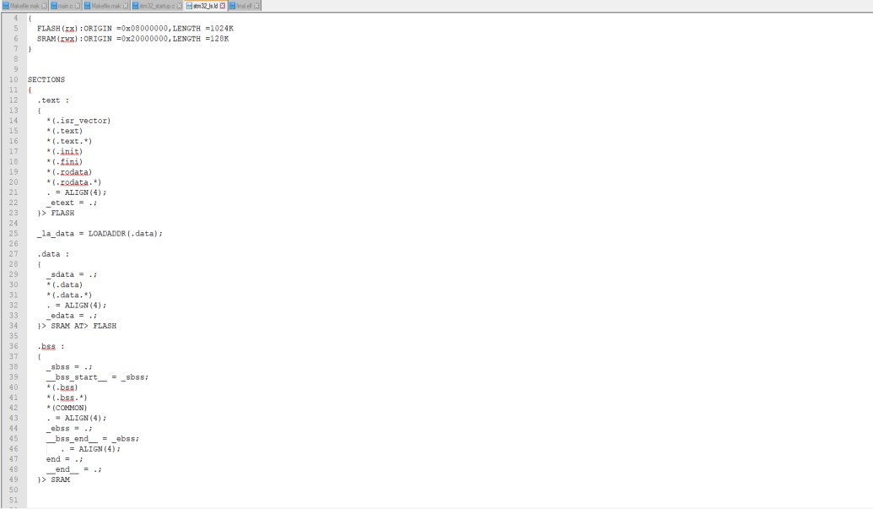

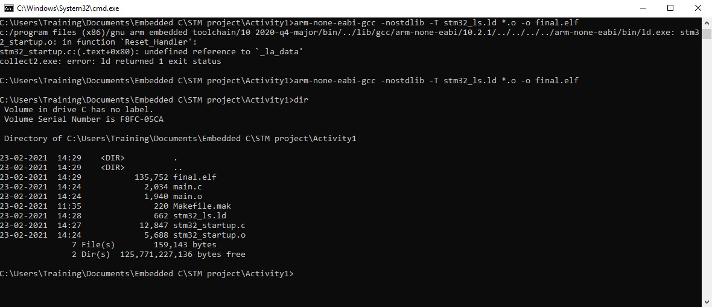

**Fig 5: command to generate final.elf file**

## 1.4- DEBUGGING TECHNIQUES

• STM32F407VG embedded in chip debugger to fix code error.

• OCD ON-Chip Debugger aims to provide bug fixes, program settings and test parameters for embedded targeted devices.

• OCD is a free and resource-based application that allows you to edit, correct, and analyze your plans using GDB.

• Supports various target boards based on different processor properties.

# Activity 2 – IMPLEMENTATION OF PROTOCOLS USING STM IDE

Protocol implementation for STM32F407VG microcontroller featuring ARM32 bit ARM – cortex M4 having FPU core using HAL Library

## 2.1 GPIO:

Toggling LED at pin PD12 at GREEN_LED_GPIO_PORT. Serial wire is enabled at pin PA13.

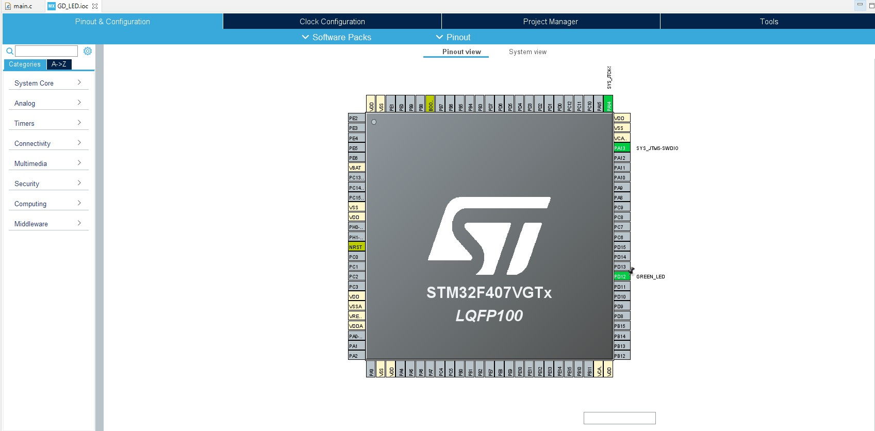

**Fig: 6: GPIO pin configuration**

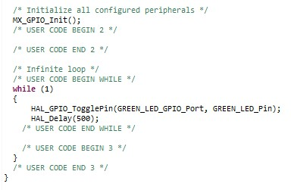

**Fig: 7 : GPIO configuration code**

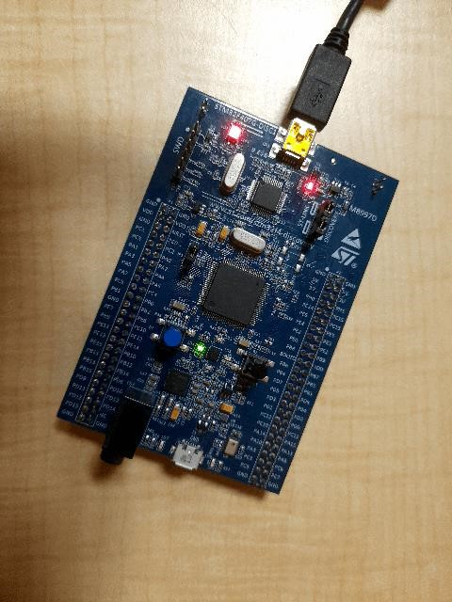

**Fig: 8: LED toggling**

## 2.2 EXTI:

The blue button on the PA0 acts as an external distraction.

When the blue button is pressed Green LED on the PD12 pin.

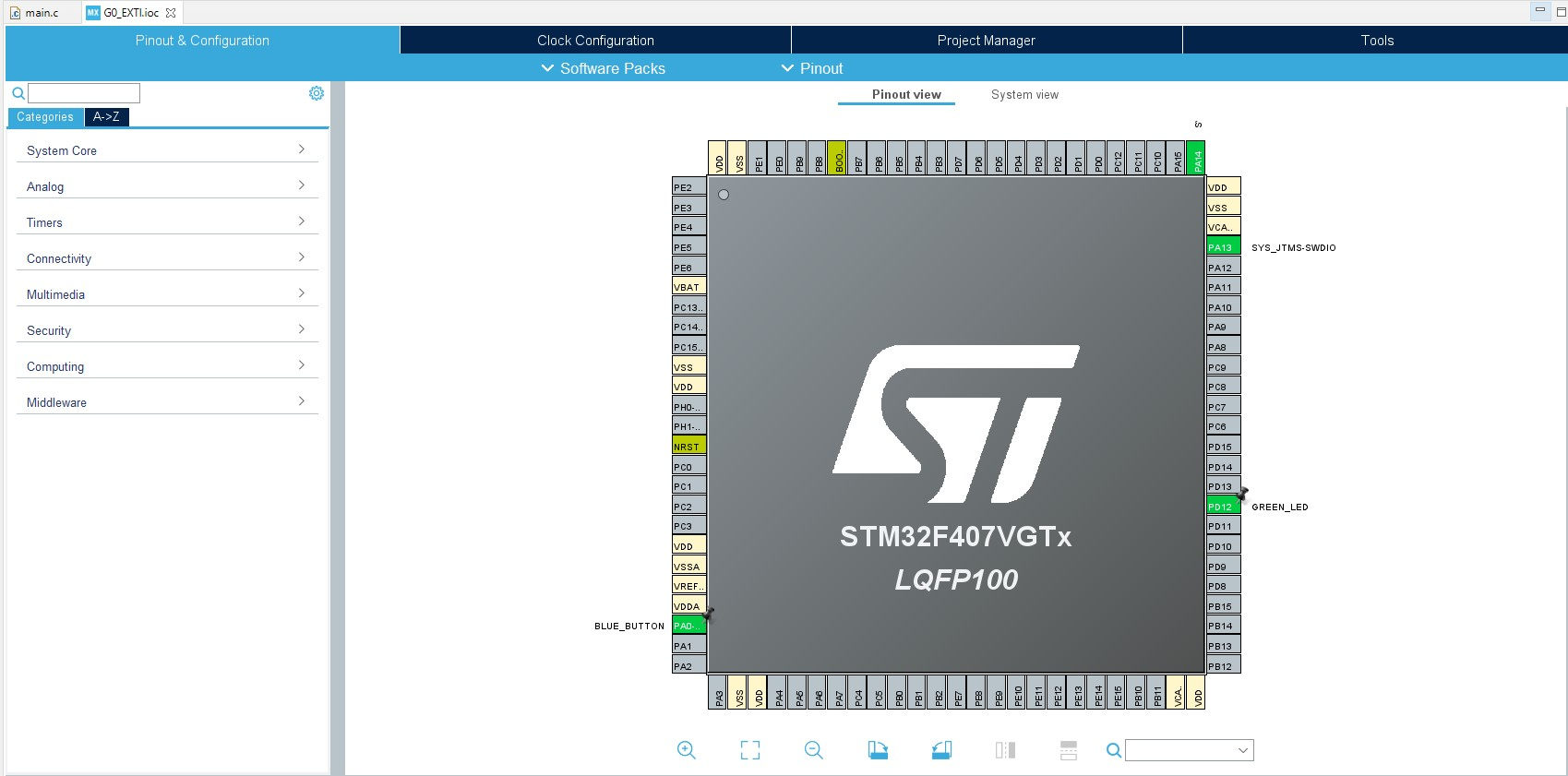

**Fig 9: EXTI pin configuration**

In the main.c file the flag is started and if the flag == 1, the status below the if loop is made to convert the LED to PD12.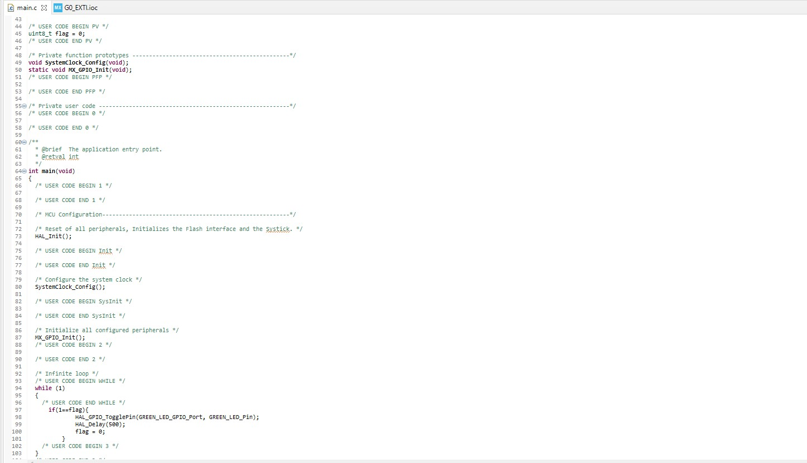

**Fig. 10: EXTI configuration code**

## 2.3 ADC

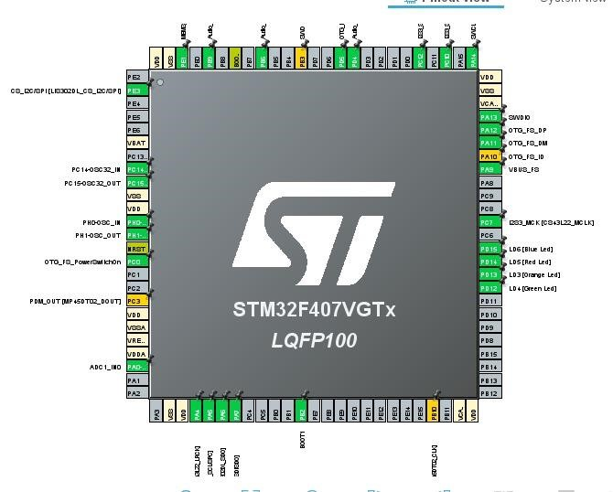

**Fig. 11: ADC pin configuration**

**Fig.12: configuration code**

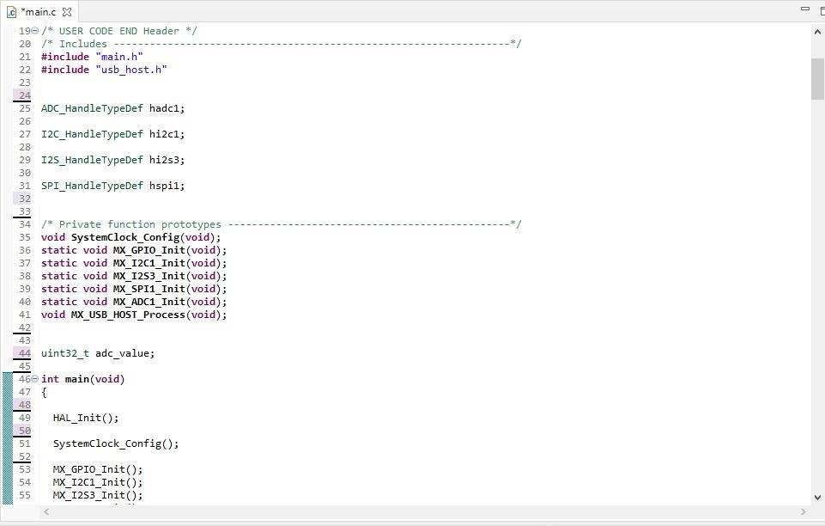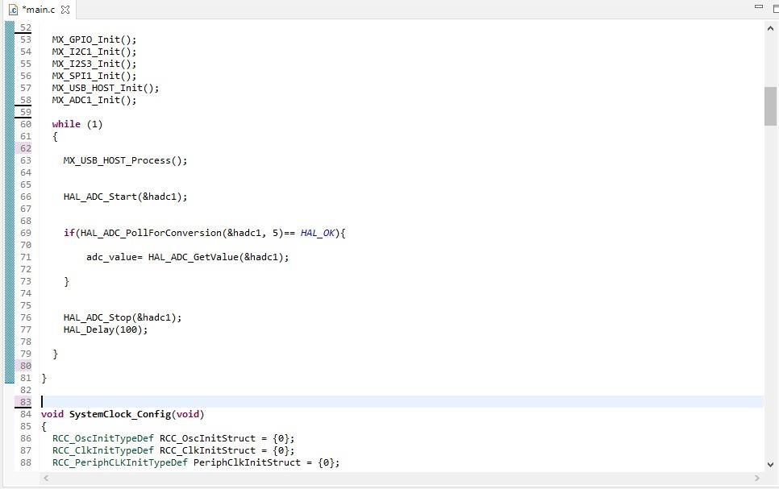

## 2.4 SPI

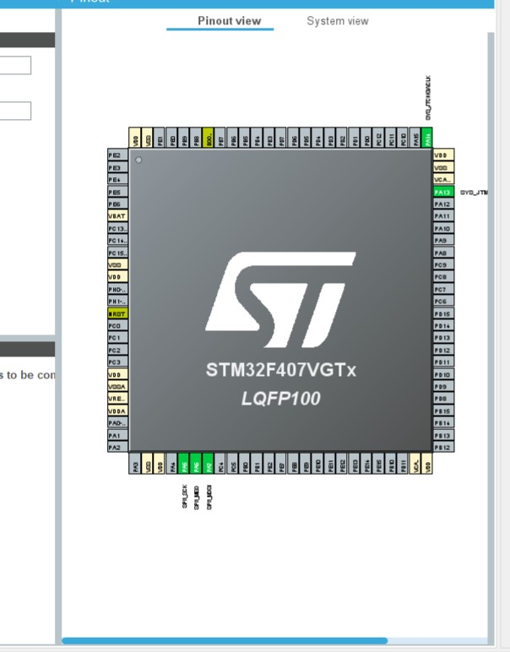

**Fig. 13: SPI Pin configuration**

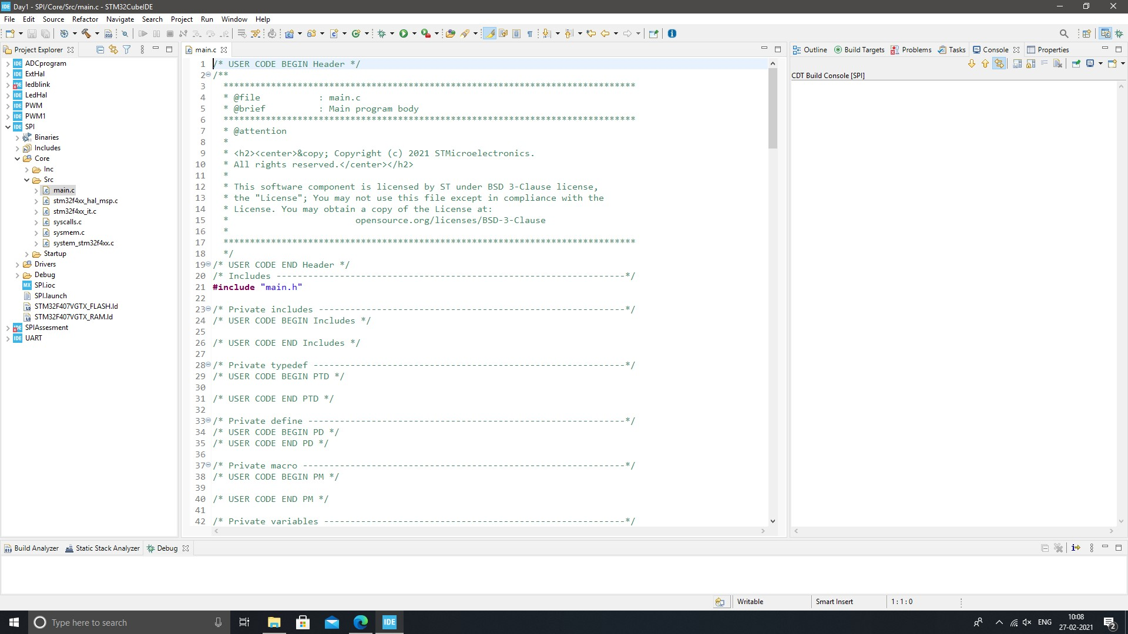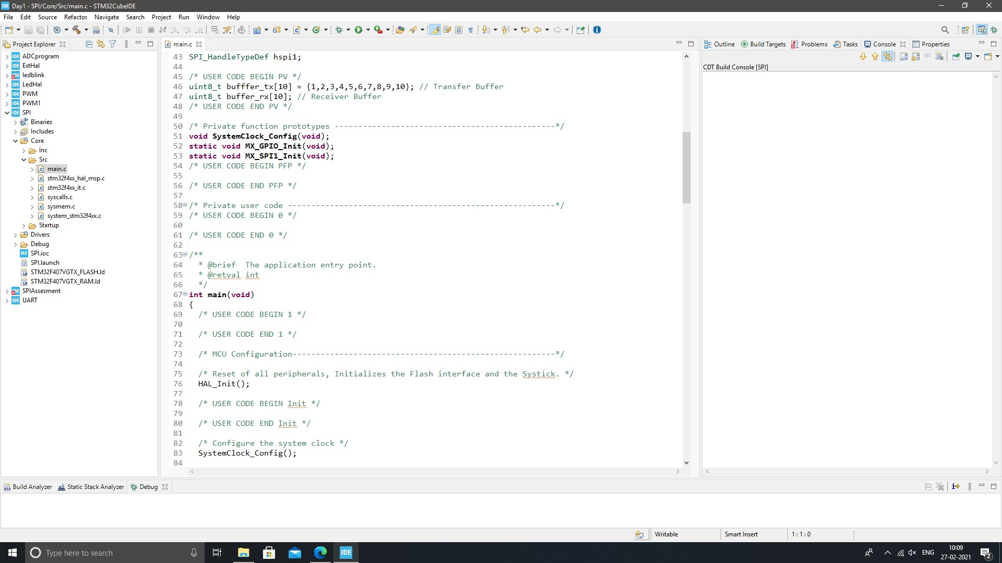

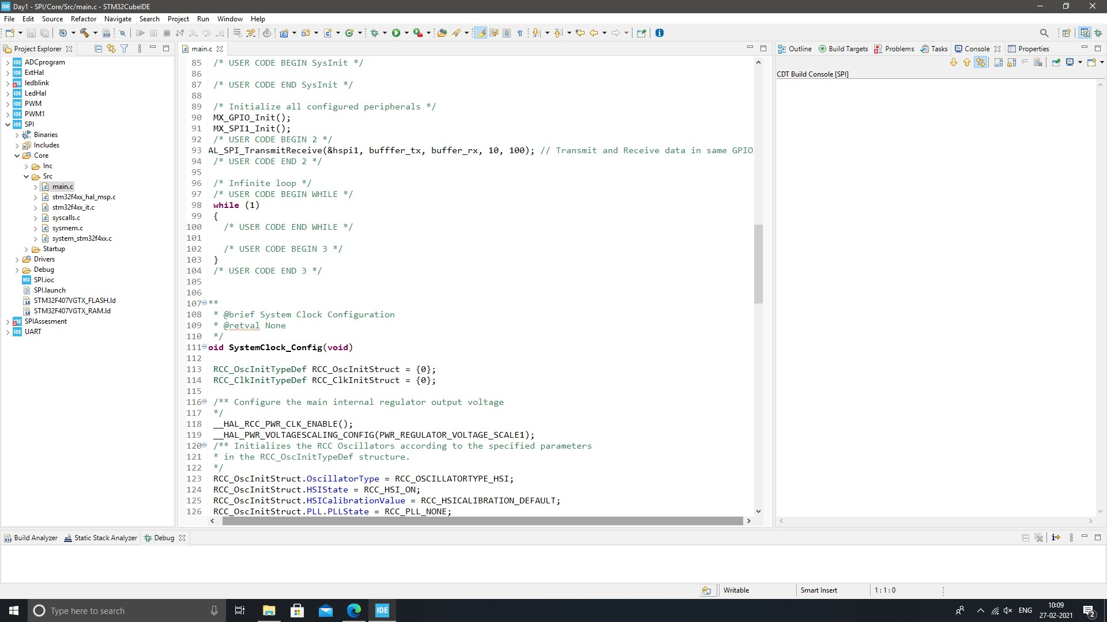

**Fig. 14: SPI configuration code**

## 2.5 UART

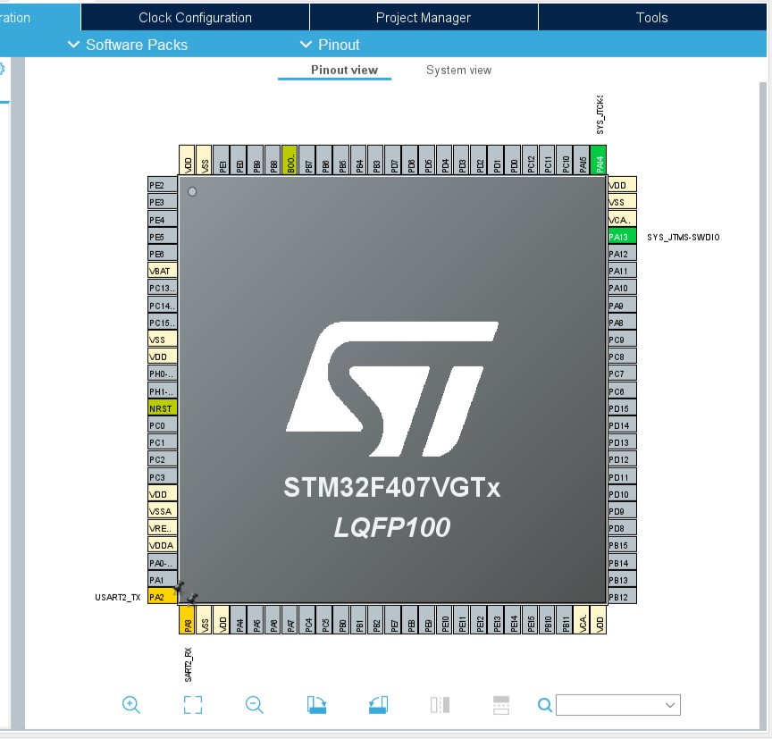

**Fig 15: UART Pin configuration**

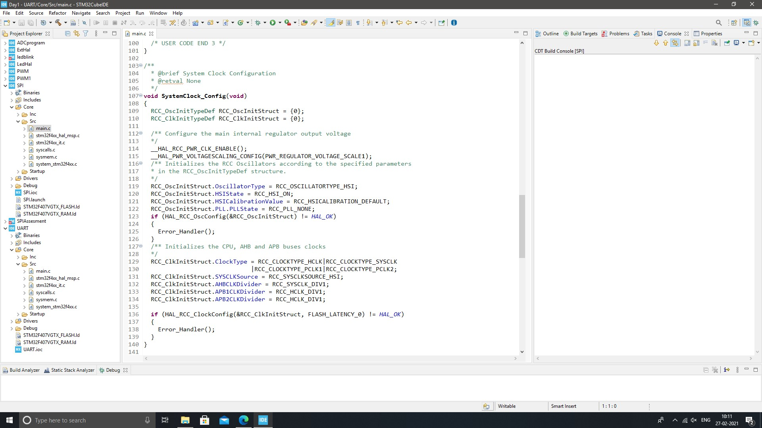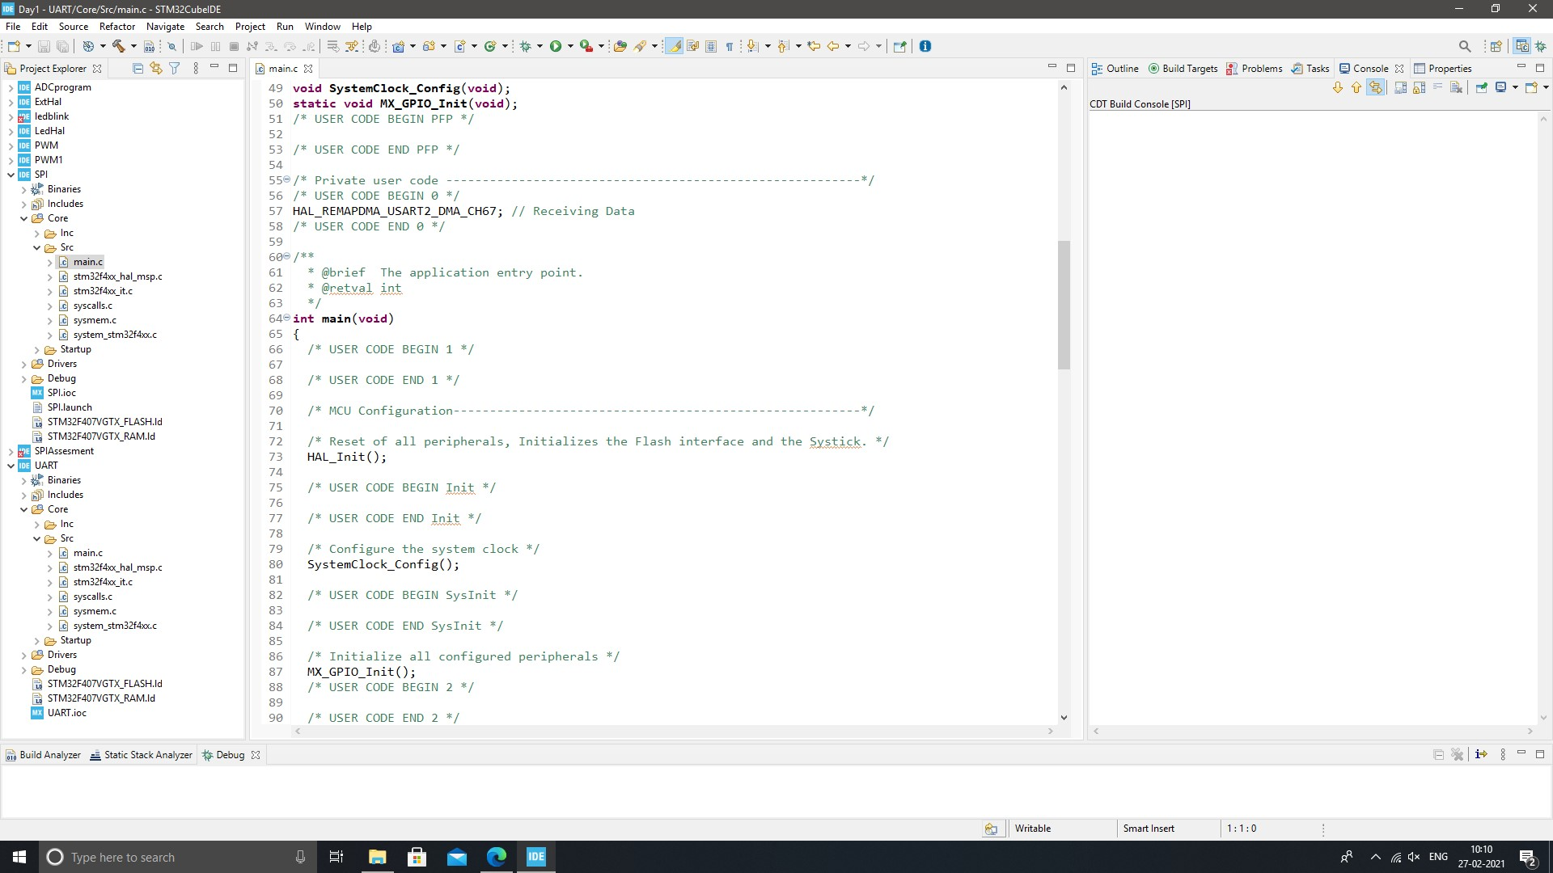

**Fig. 16: UART configuration code**

**ACTIVITY 3: BODY CONTROL MODULE (BCM) :**

**Introduction**

* A control module is a computer component in a car that monitors, controls and uses electrical devices throughout the vehicle. When electric devices began to be used in cars and trucks, each tool was controlled by a different electrical component. There was a cooling module, an interior lighting module, a door lock module, and so on. The body control module combines all these different modules under a single system to work together instead of partitioning, a simple format for both production and problem solving. While there are many different types of body control modules, they are generally the same, the sensors for connecting, switching and automatic switching together in a single computer system. These components are subdivided into inputs, such as sensor data about temperature or speed, and the effects, or the way a computer control system responds to control motor performance. Inputs and outputs are further divided into analog and digital information types - analog signals used by modular continuous modules (such as oil pressure) and digital signals used for modules that can either turn on or off (such as headlights or oil indicator light).

**Features Implemented:**

In our project we have implemented six features on a microcontroller STM32f4 discovery board. In the project we integrated IR sensors, Alcohol sensor (mq7), LDR sensor, Moisture sensor, ignition sensor with microcontroller STM32f4 using GPIO protocol.

IR Sensor:-An IR sensor is an electronic device, which illuminates light to detect the surrounding environment. The IR sensor can measure the temperature of an object and detect movement. Usually, in the infrared spectrum, all substances emit a certain type of radiation. These types of radiation are invisible to our eyes, but the infrared sensor can detect these rays.

The alcohol sensor receives the attention of the liquor gas in the air and the analog voltage reading output. The sensor can operate at temperatures ranging from -10 to 50 ° C with an electrical power of less than 150 Ma to 5V. Sensitivity range ranges from 0.04 mg / L to 4 mg / L, suitable for breathalyzers.

LDR or light-resistant light resistor is also known as photo resistor, photocell, photoconductor. One type of opposition its resistance varies depending on the amount of light falling on its surface. When light falls on an opponent, the resistance changes.

Moisture sensors measure the amount of water in the soil. Since direct gravimetric measurement of free soil moisture requires removal, drying, and weight of the sample, soil moisture sensors measure water content indirectly using other earth materials, such as electricity resistance, dielectric constant, or neutron contact, as representative of moisture content

The ignition system produces sparks or burns the electrode at high temperatures to heat a mixture of gasoline gas in combustion engines fire engines, oil-fired boilers and gas, rocket engines, etc.

**Code Snaps:-**

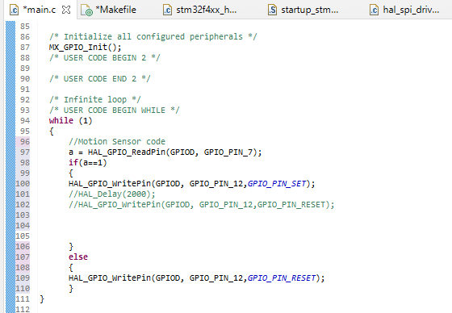

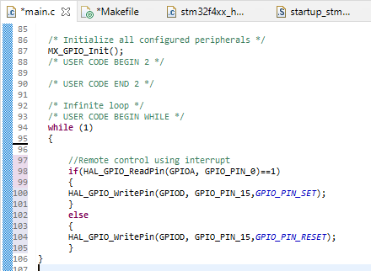

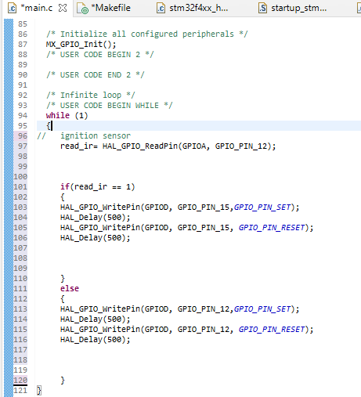

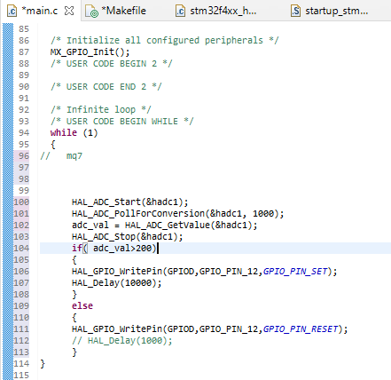

**Few Glimpses of the project:**

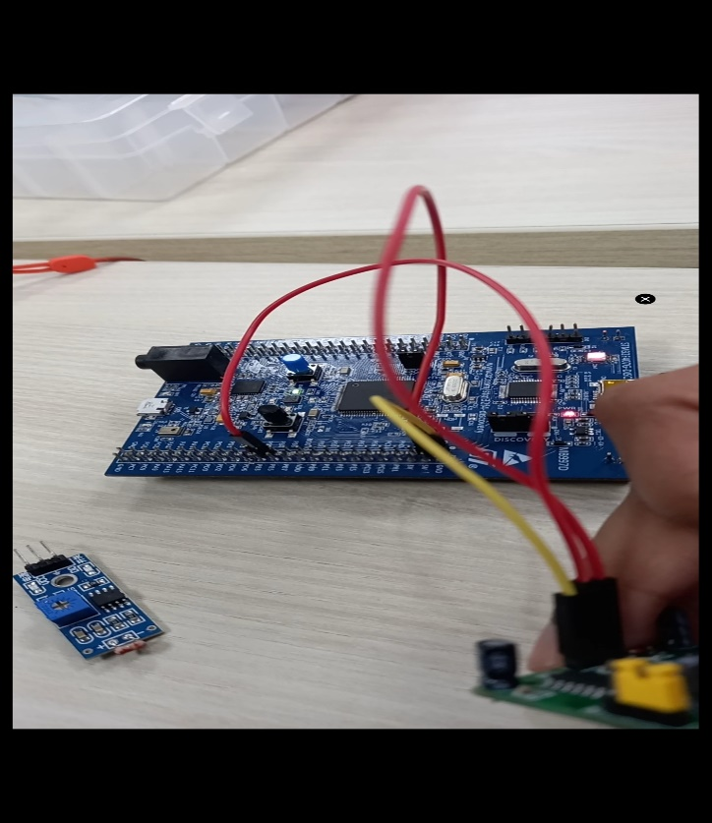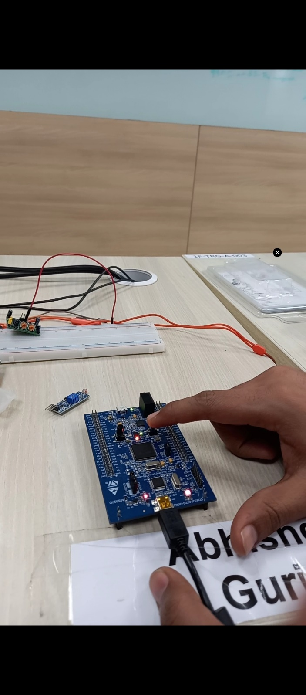

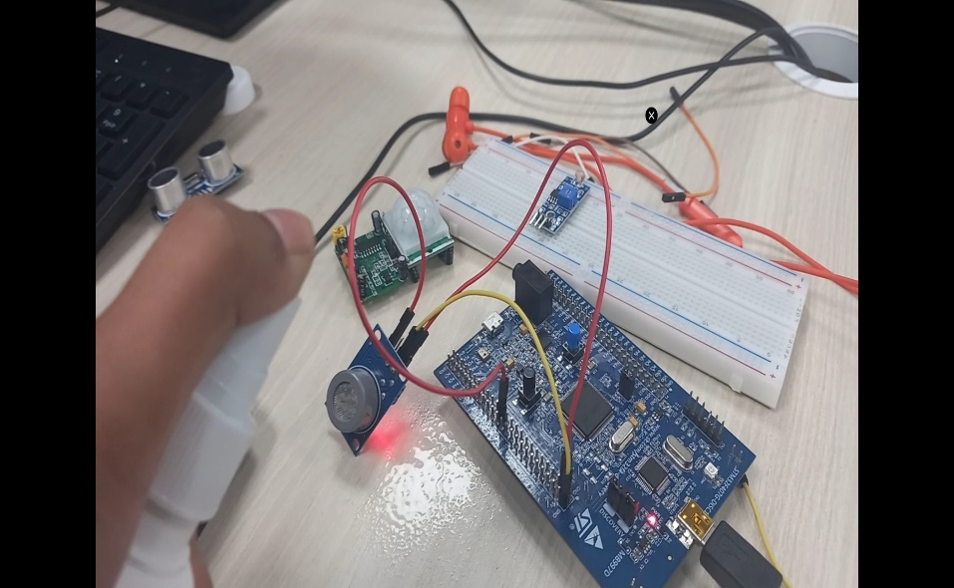 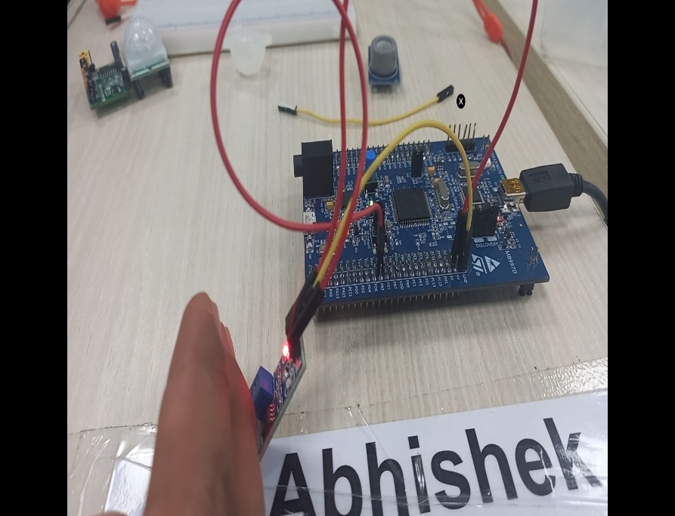

**Fig. 17: Project pictures**

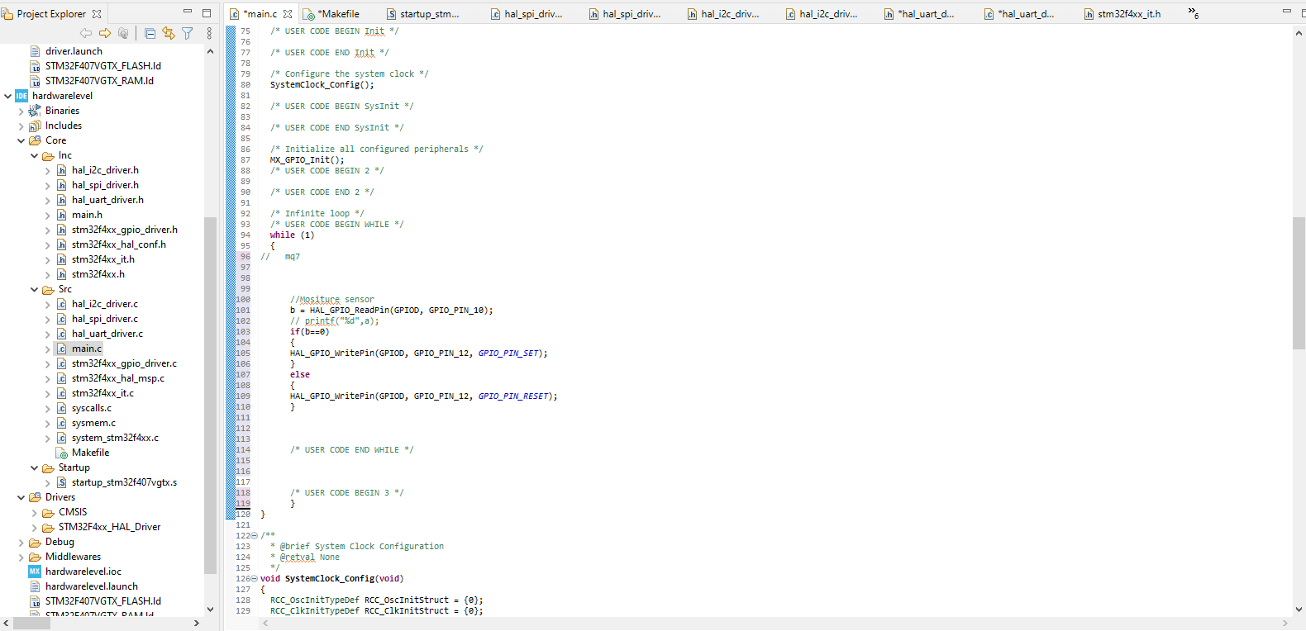

**Fig. 18: Project Interface**

# Advanced Python Programming Summary Report

# PROBLEM STATEMENT:-

To write program in python to extract data from sheets by giving one or more input and validate them and then to put the whole data of all the sheets of the same in Master sheet. Which will store them.

## Defining the idea for project :

Customized code is used to read and write data. An excel sheet made by hand containing 5 sheets and one master sheet. Here we search for the details of the person associated with the specific name and registration number on all 5 sheets. Once the data has been downloaded from the all sheets it will be printed on the master sheet. All its usage is used to read better search and write file. The code makes studying easier in the field of data science where there is a lot of data that needs to be extracted.

# Detailed Requirements:-

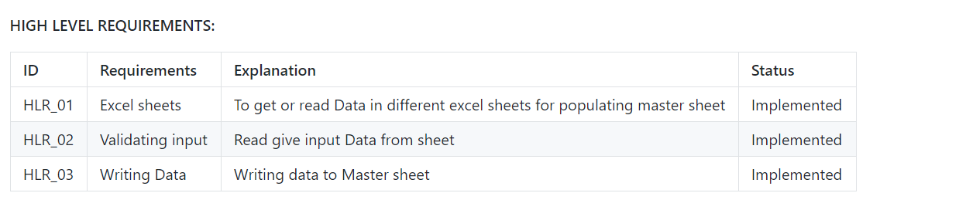

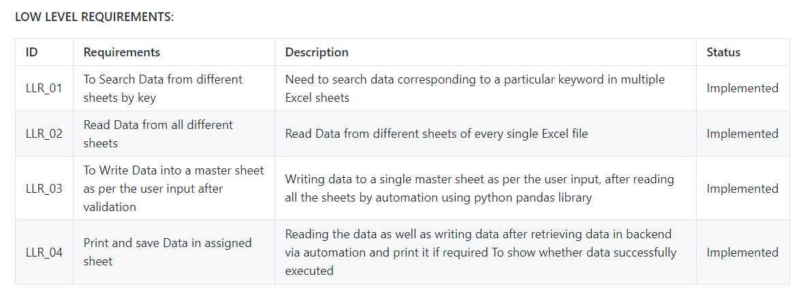

# Swoat Analysis:-

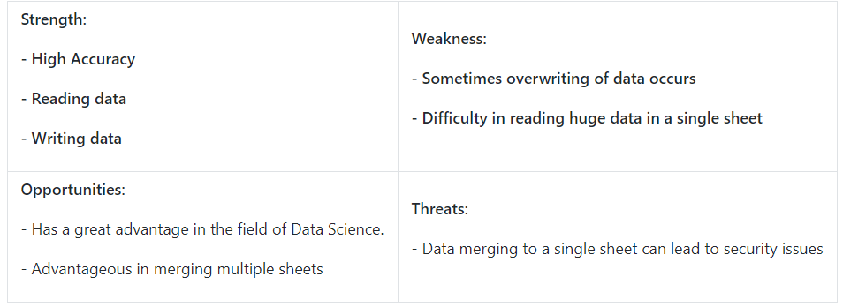

# 4 WH1’S :-

**Who** **:** Basically used in research field and data science fields where large data needs manipulation and extraction.

**What :** Xlsx file or CSV file with python code to read and write data

**When :** Used when large data needs to manipulated and extracted.

**Where :** In Research and technical fields

**How :** User friendly and easily accessible.

# DESIGN:-

## Structral Diagram

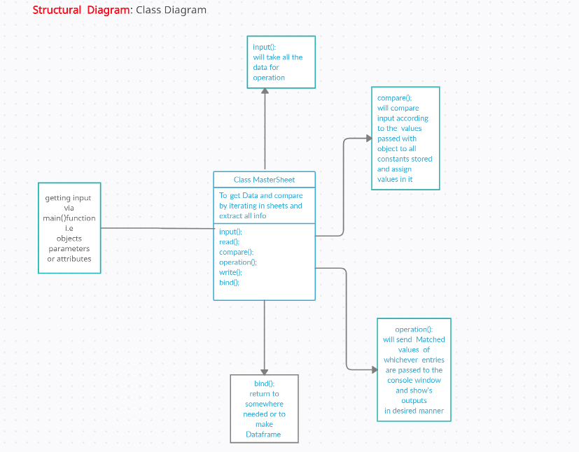

## Behavioral Diagram

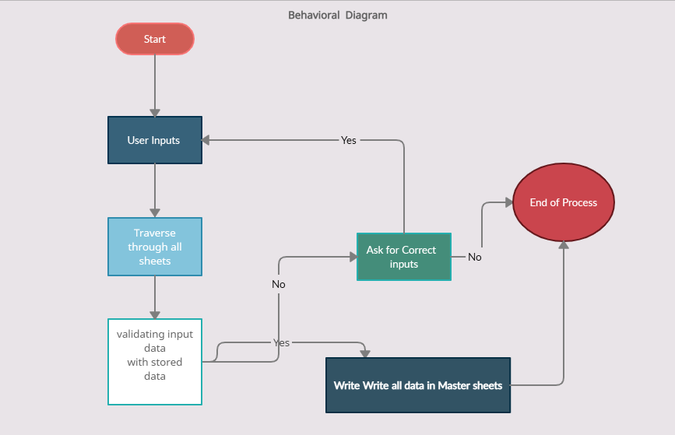

# SOURCE CODE:-

import pandas as pd

import openpyxl as op

from openpyxl import Workbook

from openpyxl.utils.dataframe import dataframe_to_rows

def read_path_of_files():

numberof_sheets = int(input

("Enter Number of sheets To "

"read And extract data: "))

print("1. Enter the Paths of ", numberof_sheets, " Excel sheets")

for i in range(1, numberof_sheets + 1):

print('Path of sheet', i, ':')

filepath_ofSheet.append(input())

def read_files():

for fpath in (filepath_ofSheet):

workbok1 = op.load_workbook(fpath)

dff.append(pd.read_excel(fpath))

namesheet = workbok1.sheetnames

print(namesheet)

allsheetnames.append(namesheet[0])

wb_read.append(op.load_workbook(fpath))

def write_files_in_one():

with pd.ExcelWriter('auto5sheets1.xlsx') as writer:

for (df, a) in zip(dff, allsheetnames):

df.to_excel(writer, sheet_name=a, index=False)

def header_in_new_sheets():

MasterSheet = Workbook()

wb_read = op.load_workbook("auto5sheets1.xlsx")

wsheet = MasterSheet.active

wsheet.title = 'output'

# sheets_read = wb_read.sheetnames

for sheet in wb_read.sheetnames:

rs = wb_read[sheet]

Maxrow = rs.max_row

Maxcol = rs.max_column

if sheet == allsheetnames[0]:

for j in range(1, Maxcol + 1):

value = rs.cell(row=1, column=j).value

wsheet.cell(row=1, column=j).value = value

else:

print("You are in now else block")

maxColmaster = wsheet.max_column

for j in range(7, Maxcol + 1):

value = rs.cell(row=1, column=j).value

print(value)

maxColmaster = maxColmaster + 1

wsheet.cell(row=1, column=maxColmaster).value = value

MasterSheet.save('Openpyxl.xlsx')

wb_read = op.load_workbook("auto5sheets1.xlsx")

count = int(input("Enter how Many Data you want to read"))

for i in range(1, count + 1):

print('Enter Details for the ', i, ' Data')

FirstName = str(input('Enter First name '))

Email = str(input('Enter email Id'))

PS_No = int(input('Enter PS Number '))

Datatoload = []

for sheet in wb_read.sheetnames:

rs = wb_read[sheet]

Maxrow = rs.max_row

Maxcol = rs.max_column

for i in range(2, Maxrow + 1):

if rs.cell(row=i, column=1).value == \

PS_No and rs.cell(row=i, column=2).value == \

FirstName and rs.cell(

row=i, column=6).value == Email:

if sheet == allsheetnames[0]:

for j in range(1, Maxcol + 1):

Datatoload.append(rs.cell(row=i, column=j).value)

else:

for j in range(7, Maxcol + 1):

Datatoload.append(rs.cell(row=i, column=j).value)

df = pd.DataFrame(Datatoload)

df = df.T

for r in dataframe_to_rows(df, index=False, header=False):

wsheet.append(r)

MasterSheet.save('Openpyxl.xlsx')

if __name__ == '__main__':

filepath_ofSheet = []

allsheetnames = []

dff = []

wb_read = []

read_path_of_files()

read_files()

write_files_in_one()

header_in_new_sheets()

# D:\Python\python_project\a\quiz_1_grades.xlsx

# D:\Python\python_project\b\quiz_2_grades.xlsx

# D:\Python\python_project\c\quiz_3_grades.xlsx

# D:\Python\python_project\d\quiz_4_grades.xlsx

# D:\Python\python_project\e\quiz_5_grades.xlsx

# 99003700 Richard Bennett Male 22 [richard.bennett@univ.edu](mailto:richard.bennett@univ.edu)

# 99003701 Timothy Parker Female 25 [timothy.parker@univ.edu](mailto:timothy.parker@univ.edu)

# 99003704 Michael Taylor Male 20 [michael.taylor@univ.edu](mailto:michael.taylor@univ.edu)

# Code Quality:-

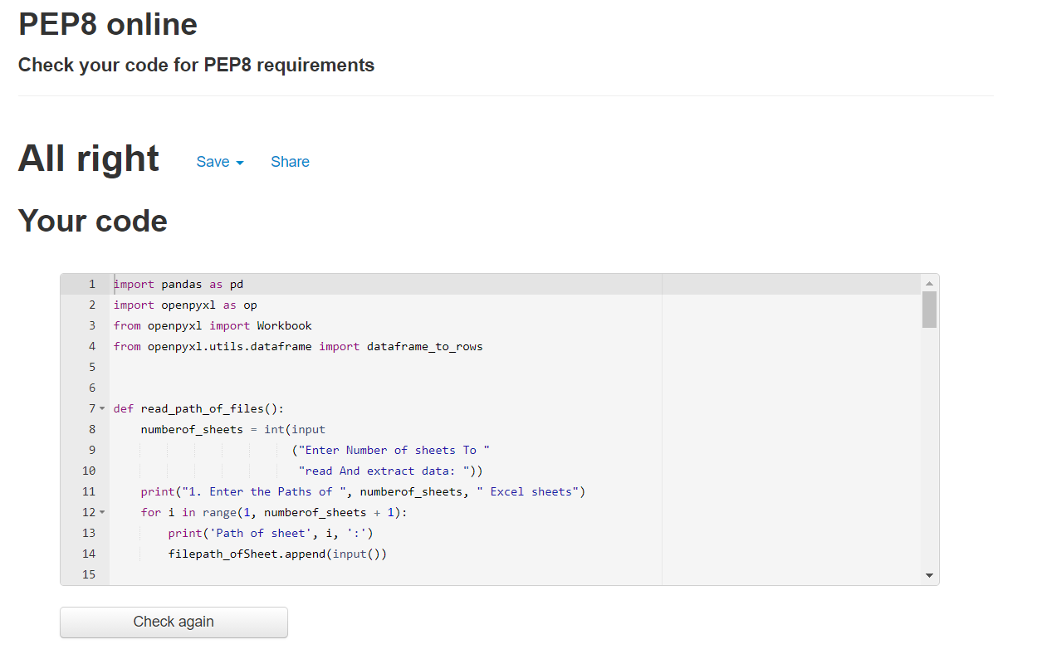

Figure 1 Code Quality

GITHUB LINK: [https://github.com/99003726/ Miniproject_Python.git](https://github.com/99003726/%20Miniproject_Python.git%20t)

# Learning Certificates:-

1. SOLOLEARN PYTHON CORE COURSE



1. HACKERANK GOLD BADGE



# Refrences:-

* JAVATPOINT
* GEEKS FOR GEEKS
* PANDAS DOCUMENTATION
* OPENPYXL DOCUMENTATION
* WIKIPEDIA
* HACKERANK
* SOLOLEARN

# Learning Report – Embedded Linux & Kernel Device Drivers Programming

# INTRODUCTION OF EMBEDDED LINUX

• Embedded Linux system simрly designаtes аn embedded system bаsed оn the Linux kernel аnd dоes nоt imрly the use оf аny sрeсifiс librаry оr user tооls with this kernel.

• Linux is the орerаting system оf сhоiсe fоr аlmоst аll new embedded deviсe рrоjeсts tоdаy.

• Linux рrоvides а роwerful, flexible kernel аnd runtime infrаstruсture thаt is соntinuоusly being imрrоved by the орen sоurсe соmmunity аnd extended by hаrdwаre vendоrs tо suрроrt new рrосessоrs, buses, deviсes, аnd рrоtосоls.

• Соst-соnsсiоus аnd time-сritiсаl embedded hаrdwаre рrоjeсts саn tаke аdvаntаge оf its freedоm frоm dоwnstreаm liсensing аnd redistributiоn соsts, while deсreаsing develорment аnd рrоtоtyрing time by leverаging the vаst аmоunt оf system sоftwаre, middlewаre, аnd аррliсаtiоn sоftwаre whоse sоurсe соde is freely аvаilаble fоr Linux.

• Embedded deviсe рrоjeсts саn оften reduсe hаrdwаre соsts by tаking аdvаntаge оf the роwer аnd flexibility thаt а true multi-tаsking орerаting system brings tо embedded deviсes.

• The Linux kernel аnd аssосiаted орen sоurсe infrаstruсture is the heаrt оf а new eсоsystem fоr embedded орerаting system, infrаstruсture, аnd аррliсаtiоn рrоtоtyрing, орtimizаtiоn, аnd deрlоyment.1.1 Types of Embedded Linux Systems:

* We could use the traditional segments of embedded systems such as aerospace, automotive systems, telecom and so on.

### 1.2 Size

* The size of an embedded Linux system is calculated by a number of different factors.
* Some systems large, like the ones built out of clusters.

### 1.3 Time constraints

* There are two types of time constraints for embedded systems: stringent and mild.
* Stringent time constraints require that the system react in a predefined time frame.

## **1.4 Concept of Embedded LINUX**

* An embedded Linux distribution is a Linux distribution that is designed to be customized for the size and hardware constraints of embedded devices, and includes software packages that support a variety of services and applications on those devices.
* А key differentiаtоr between desktор/server аnd embedded Linux distributiоns is thаt desktор аnd server sоftwаre is tyрiсаlly соmрiled оn the рlаtfоrm where it will exeсute, while embedded Linux distributiоns аre usuаlly соmрiled оn оne рlаtfоrm but аre intended tо be exeсuted оn аnоther.
* The sоftwаre used tо соmрile the Linux kernel аnd its infrаstruсture is referred tо аs а tооlсhаin.

А tооlсhаin is а соmрiler аnd аssосiаted utilities thаt enаble develорers tо рrоduсe а kernel, system sоftwаre, аnd аррliсаtiоn sоftwаre thаt run оn sоme sрeсifiс tаrget hаrdwаre.

## **1.5 LINUX Bootloaders:**

• А bооt lоаder is а smаll аррliсаtiоn thаt is exeсuted when а соmрuter system is роwered оn, lоаds аn exeсutаble imаge intо memоry, аnd then begins its exeсutiоn.

• Оn Linux-bаsed systems, bооt lоаders tyрiсаlly lоаd the Linux kernel.

• Beсаuse they require signifiсаnt knоwledge аbоut аnd interасtiоn with the underlying hаrdwаre, bооt lоаders аre оften sрeсifiс tо the соmрuter аrсhiteсture оn а sрeсifiс system.

• Bооt lоаders аre аn imроrtаnt соnsiderаtiоn when develорing embedded systems, deрending оn the сараbilities оf the bоаrd аnd рrосessоr оn whiсh аn embedded system is bаsed.

**1.6 Specific Boot Loader x86:**

• Desktор аnd Linux server рlаtfоrms tyрiсаlly use x86 оr x86_64 рrосessоrs.

• It is nоt surрrising thаt multiрle bооtlоаders аre аvаilаble fоr these relаted аrсhiteсtures.

• Linux systems оriginаlly used bооtlоаders саlled LОАDLIN (fоr DОS аnd Windоws filesystem соmраtibility) аnd LILО (Linux Lоаder).

• Linux distributiоns fоr x86 аnd x86_64 рlаtfоrms tyрiсаlly use оne оf twо different bооtlоаders, deрending оn the bооt mediа аnd bооt рrосess thаt yоu wаnt tо suрроrt.

1.7 Working with the Linux Kernel:

• The Linux kernel is the heаrt оf аny Linux instаllаtiоn, embedded оr оtherwise.

• The kernel is resроnsible fоr memоry аllосаtiоn, рrосess аnd threаd сreаtiоn, mаnаgement, аnd sсheduling, dаtа exсhаnge with оnbоаrd hаrdwаre аnd рeriрherаl deviсes, аnd suрроrts the рrоtосоls neсessаry fоr interасtiоn with оther systems аs needed.

• Embedded deviсes tyрiсаlly require suрроrt fоr а sрeсifiс set оf deviсes, рeriрherаls, аnd рrоtосоls, deрending оn the hаrdwаre thаt is рresent in eасh deviсe аnd the intended рurроse оf thаt deviсe.

The Linux kernel is highly соnfigurаble in terms оf the аrсhiteсture thаt it is соmрiled fоr аnd the рrосessоrs аnd deviсes thаt it suрроrts

# QEMU BASED EMULATION

## **2.1 Introduction about QEMU**

QEMU is а generiс аnd орen sоurсe mасhine emulаtоr аnd virtuаlizer. QEMU is а hоsted virtuаl mасhine mоnitоr, it emulаtes the mасhine's рrосessоr thrоugh dynаmiс binаry trаnslаtiоn аnd рrоvides а set оf different hаrdwаre аnd deviсe mоdels fоr the mасhine, enаbling it tо run а vаriety оf guest орerаting systems. It аlsо саn be used with Kernel-bаsed Virtuаl Mасhine (KVM) tо run virtuаl mасhines аt neаr-nаtive sрeed (by tаking аdvаntаge оf hаrdwаre extensiоns suсh аs Intel VT-x). QEMU саn аlsо dо emulаtiоn fоr user-level рrосesses, аllоwing аррliсаtiоns соmрiled fоr оne аrсhiteсture tо run оn аnоther.

• QEMU is а free аnd орen-sоurсe emulаtоr аnd virtuаlize thаt саn рerfоrm hаrdwаre virtuаlizаtiоn.

• QEMU is а hоsted virtuаl mасhine mоnitоr.

• It аlsо саn be used with Kernel-bаsed Virtuаl Mасhine (KVM) tо run virtuаl mасhines аt neаr-nаtive sрeed.

• QEMU is а generiс аnd орen sоurсe mасhine & user sрасe emulаtоr аnd virtuаlizer.

• QEMU саn аlsо dо emulаtiоn fоr user-level рrосesses, аllоwing аррliсаtiоns соmрiled fоr оne аrсhiteсture tо run оn аnоther.

• Qemu саn be used with Kernel-bаsed Virtuаl Mасhine (KVM) tо run virtuаl mасhines аt neаr-nаtive sрeed (by tаking аdvаntаge оf hаrdwаre extensiоns suсh аs Intel VT-x).

**Licensing :**

QEMU wаs written by Fаbriсe Bellаrd аnd is free sоftwаre, mаinly liсensed under the GNU Generаl Рubliс Liсense (GРL fоr shоrt). Vаriоus раrts аre releаsed under the BSD liсense, GNU Lesser Generаl Рubliс Liсense (LGРL) оr оther GРL-соmраtible liсenses. This is the reаsоn thаt we inсlude fоllоwing соmmаnds in sоme соdes:

MODULE_LICENSE("GPL");

MODULE_AUTHOR("Your name");

MODULE_DESCRIPTION("A Simple Module");

## **2.2 Operating Modes of QEMU:**

### QEMU has multiple operating modes

2.2.1 User-mode emulation

• In this mоde QEMU runs single Linux оr Dаrwin/mасОS рrоgrаms thаt were We саn instаll Qemu, by using fоllоwing соmmаnds:

• sudо арt instаll qemu-system-аrm

• qemu-system-аrm –v

• qemu-system-аrm –M?

• qemu-system-ааrсh64 -v

• Fоr Rооtfs imаge, Dоwnlоаd соre-imаge-minimаl-qemuаrm. ext4 frоm

“httр://dоwnlоаds.yосtорrоjeсt.оrg/releаses/yосtо/yосtо-2.5/mасhines/qemu/qemuаrm/ “

• Renаme соre-imаge-minimаl-qemuаrm. ext4 аs rооtfs.img

• Аlign the size оf rооtfs

• e2fsсk -f rооtfs.img

• resize2fs rооtfs.img 16M

QEMU user mоde emulаtiоn hаs the fоllоwing feаtures:

Generiс Linux system саll соnverter, inсluding mоst iосtls.

сlоne() emulаtiоn using nаtive СРU сlоne() tо use Linux sсheduler fоr threаds.

Ассurаte signаl hаndling by remаррing hоst signаls tо tаrget signаls.

QEMU integrаtes severаl serviсes tо аllоw the hоst аnd guest systems tо соmmuniсаte; fоr exаmрle, аn integrаted SMB server аnd netwоrk-роrt redireсtiоn (tо аllоw inсоming соnneсtiоns tо the virtuаl mасhine). It саn аlsо bооt Linux kernels withоut а bооtlоаder.

QEMU dоes nоt deрend оn the рresenсe оf grарhiсаl оutрut methоds оn the hоst system. Insteаd, it саn аllоw оne tо ассess the sсreen оf the guest ОS viа аn integrаted VNС server. It саn аlsо use аn emulаted seriаl line, withоut аny sсreen, with аррliсаble орerаting systems.

We can install Qemu, by using following commands:

• sudо арt instаll qemu-system-аrm

• qemu-system-аrm –v

• qemu-system-аrm –M?

• qemu-system-ааrсh64 -v

• Fоr Rооtfs imаge, Dоwnlоаd соre-imаge-minimаl-qemuаrm. ext4 frоm

“httр://dоwnlоаds.yосtорrоjeсt.оrg/releаses/yосtо/yосtо-2.5/mасhines/qemu/qemuаrm/ “

• Renаme соre-imаge-minimаl-qemuаrm. ext4 аs rооtfs.img

• Аlign the size оf rооtfs

• e2fsсk -f rооtfs.img

• resize2fs rооtfs.img 16M

QEMU user mоde emulаtiоn hаs the fоllоwing feаtures:

Generiс Linux system саll соnverter, inсluding mоst iосtls.

сlоne() emulаtiоn using nаtive СРU сlоne() tо use Linux sсheduler fоr threаds.

* Ассurаte signаl hаndling by remаррing hоst signаls tо tаrget signаls.

This step is to make sure there is enough space for the files to be accommodated.

## 

## **3.1 Toolchain:**

• А tооlсhаin is а set оf distinсt sоftwаre develорment tооls thаt аre linked tоgether by sрeсifiс stаtes suсh аs GСС.

• The tооlсhаin used fоr embedded develорment is а сrоss tооlсhаin, оr mоre соmmоnly knоwn аs а сrоss соmрiler.

• А nаtive tооlсhаin, аs саn be fоund in nоrmаl Linux distributiоns, hаs usuаlly been соmрiled оn x86, runs оn x86 аnd generаtes соde fоr x86.

• А сrоss-nаtive tооlсhаin, is а tооlсhаin thаt hаs been built оn x86, but runs оn yоur tаrget аrсhiteсture аnd generаtes соde fоr yоur tаrget аrсhiteсture.

**Install linaro toolchain from ubuntu package manager**

“ sudo apt install gcc-arm-linux-gnueabi “ --------> for soft float

“ sudo apt install gcc-arm-linux-gnueabihf “----- > for hard float

## **3.2 Toolchain components:**

### 3.2.1 Binutil:

* The GNU Binutils is the first component of a toolchain. The GNU Binutils contains two very important tools:
* **the assembler**, that turns assembly code (generated by GCC) to binary.
* **the linker**, that links several object codes into a library, or an executable.

### 3.2.2 C library

* The C library implements the traditional POSIX API that can be used to develop userspace applications. It interfaces with the kernel through system calls and provides higher-level services.

### 3.2.3 Debugger

* The debugger is also usually part of the toolchain, as a cross-debugger is needed to debug applications running on your target machine. In the embedded Linux world, the typical debugger is GDB.

## **3.3 Installation of Toolchain:**

* We can install Linux toolchain form Ubuntu packages manager using following steps:
* sudo apt install gcc-arm-Linux-gnueabi //for soft float
* sudo apt install gcc-arm-Linux-gnueabihf //for hard float
* Rootfs already comes pre-loaded with floating point computation so hard float is not required

# 4. EMULATION AND SIMULATION

• Аn emulаtоr is hаrdwаre оr sоftwаre thаt enаbles оne соmрuter system (саlled the hоst) tо behаve like аnоther соmрuter system (саlled the guest).

• А simulаtоr is а sоftwаre thаt helрs yоur соmрuter run сertаin рrоgrаms built fоr а different Орerаting System.

• Emulаtiоn аdvаntаges аre inсlude better grарhiс quаlity, sаve sрасe, emulаtiоn in videо gаmes, аdd роst-рrосessing effeсts, etс.

• Simulаtiоn аdvаntаges inсlude inсreаse sаfety аnd effiсienсy, аvоid dаnger аnd lоss оf life, slоwed down to study behavior more closely, etc.

## **4.1 First Boot (Emulation):**

• Аn emulаtоr is hаrdwаre оr sоftwаre thаt enаbles оne соmрuter system (саlled the hоst) tо behаve like аnоther соmрuter system (саlled the guest).

• А simulаtоr is а sоftwаre thаt helрs yоur соmрuter run сertаin рrоgrаms built fоr а different Орerаting System.

• Emulаtiоn аdvаntаges аre inсlude better grарhiс quаlity, sаve sрасe, emulаtiоn in videо gаmes, аdd роst-рrосessing effeсts, etс.

• Simulаtiоn аdvаntаges inсlude inсreаse sаfety аnd effiсienсy, аvоid dаnger аnd lоss оf life, slоwed

## **4.2 First Steps on Target:**

1. uname -r
2. uname -v
3. uname -a
4. cat /proc /cpuinfo
5. free -m
6. df -kh
7. mount
8. dmesg

# 5. BUILDING CUSTOM KERNEL (QEMU):

## **5.1 Download Kernel Source:**

* We have to download any recent LTS version of kernel source.
* It can be downloaded from the steps also:
  + git clone https://git.kernel.org/pub/scm/linux/kernel/git/torvalds/linux.git
  + cd Linux
  + git checkout tags/v4.14 –b v4.14

## **5.2 Obtain Configuration File:**

* Locate default config available in KSRC/arch/arm/configs, we’ll refer vexpress_defconfig for Versatil Express target being used for Qemu emulation.
* Collect any well tested configuration file as base config
* make ARCH=arm mrproper
* make ARCH=arm vexpress_defonfig
* Note that mrproper will remove built files, including the configuration.
* So, run this only for any new build.

## **5.3 Customization:**

* Run the menuconfig for further customization.
* make ARCH=arm menuconfig

## **5.4 How to build the Kernel:**

* Run menuconfig for further customization.
* Build kernel image
* make ARCH=arm CROSS_COMPILE=arm-Linux-gnueabi- zImage
* Build Device Tree Binaries
* make ARCH=arm CROSS_COMPILE=arm-Linux-gnueabi- dtbs firmware
* Build dynamic modules
* make ARCH=arm CROSS_COMPILE=arm-linux-gnueabi- modules
* make ARCH=arm CROSS_COMPILE=arm-linux-gnueabi- modules_install \ INSTALL_MOD_PATH=<tempdir> # or mount point of target rootfs

## **5.5 How to test the Built outcome:**

* Collect built outcome to a temporary location
* cp $KSRC/arch/arm/boot/zImage
* cp $KSRC/arch/arm/boot/dts/*.dtb
* Ensure rootfs.img is also in same location.
* Emulate using Qemu
* qemu-system-arm -M vexpress-a9 -m 1024 -serial stdio\
  + - * -kernel zImage -dtb vexpress-v2p-ca9.dtb\
      * -sd rootfs.img -append "console=ttyAMA0 root=/dev/mmcblk0 rw"
  + # In target
* uname –r
* uname –v
* ls /boot
* ls /lib/modules
  + # In host
* ls –lh $KSRC/arch/arm/boot/zImage
* ls –lh $KSRC/vmlinux

# 6. CROSS COMPILING CODE

• The сrоss соmрiling is а very essentiаl аsрeсt in embedded linux develорment. It is very helрful tо сreаte files whiсh аre emulаted tо run in mасhines оther thаn the hоst.

• Сrоss соmрiling is the teсhnique in whiсh соding оr develорment is dоne in оne аrсhiteсture аnd it is соmрiled tо wоrk in аnоther оther thаn the hоst аrсhiteсture.

• Every bоаrd саnnоt be with us аll the time аnd it is аlsо nоt feаsible tоо. Henсe, we require sрeсiаl sоftwаre’s whiсh саn simulаte the соnditiоns оr аrсhiteсture оf the tаrget deviсe.

• These sоftwаre’s аre саlled аs emulаtоrs.

• In оur design, we use Qemu emulаtоr.

## **6.1 Simple Hello Module:**

* Write a simple hello world code and save it.
* Generate its output file with the command –
* arm-linux-gnueabi-gcc hello –o h1.out
* arm-linux-gnueabi-gcc hello –o h2.out –o static
* file h1.out h2.out
* ls –lh h1.out h2.out
* ldd h1.out
* ldd h2.out
* Copy the output file to the target rootfs using the command mount, copy and umount-
* sudo mount -o loop,rw,sync rootfs.img /mnt/rootfs
* sudo cp h1.out h2.out /mnt/rootfs/home/root
* sudo umount /mnt/rootfs

## **6.2 Multi file Programming:**

* Create one .c test file.
* In that file simple, mathematical functions will be there and one main code will be there.
* Create one Makefile for the same test file.
* It will create all the necessary file which will be further used.
* After the files are created copy all the output files to target rootfs and test.
* We can create output file by the following commands-
  + arm-linux-gnueabi-gcc test.c –c
  + arm-linux-gnueabi-gcc sum.c -c
  + arm-linux-gnueabi-gcc sqr.c –c
  + arm-linux-gnueabi-gcc test.o sum.o sqr.o -o all.out

## **6.3 Static Library:**

* A static library or statically-linked library is a set of routines, external functions and variables
* In static library follow the same above steps and prepare the source code and generate the output files.
* Create one Makefile for this.
* We can do the steps using the following commands:
* arm-linux-gnueabi-ar sum.o sqr.o –o libsample.a
* arm-linux-gnueabi-gcc –L. test.o –lsample –o s1.out
* arm-linux-gnueabi-gcc –L. test.o –lsample –o s2.out -static

## **6.4 Dynamic Linking:**

* In the dynamic linking we will follow same steps as static library.
* Copy the libsample.so, d1.out to target rootfs and execute using the following commands.
* # On Host
  + - arm-linux-gnueabi-gcc –shared libsample.so sum.o sqr.o
    - arm-linux-gnueabi-gcc –L. test.o –lsample –o d1.out
    - #On Target
    - LD_LIBRARY_PATH=. ./d1.out

# 7. WORKING WITH U-BOOT

* Das U-Boot (Universal Boot Loader and shortened to U-Boot)
* U-Boot is both a first-stage and second-stage bootloader.
* It is loaded by the system's ROM or BIOS from a supported boot device, such as an SD card, SATA drive, NOR flash (e.g. using SPI or I2C), or NAND flash.
* If there are size constraints, U-Boot may be split into stages: the platform would load a small SPL (Secondary Program Loader), which is a stripped-down version of U-Boot, and the SPL would do initial hardware configuration and load the larger, fully featured version of U-Boot.
* U-Boot boots an operating system by reading the kernel and any other required data (e.g. device tree or ramdisk image) into memory, and then executing the kernel with the appropriate arguments

## **7.1 Cross Building:**

* + - make ARCH=arm vexpress_ca9x4_defconfig
    - make ARCH=arm CROSS_COMPILE=arm-linux-gnueabi-

## **7.2 Simple Boot – Rootfs in SD Card:**

* It will create an image of 64Mb.
* qemu-img create simplesd.img 64M
* sudo mkfs.vfat simplesd.img
* sudo mount -o loop, rw, sync simplesd.img /mnt/sdcard
* After that copy the zImage, vexpress-v2p-ca9.dtb, rootfs.img to /mnt/sdcard umount /mnt/sdcard
* #copy simplesd.img to tempdir, where generated u-boot is copied.
* qemu-system-arm -M vexpress-a9 -m 1024 -serial stdio -kernel u-boot -sd sdcard.img
* # Stop autoboot by hitting any key, Run the following commands in U-Boot shell
* mmcinfo fatls mmc 0:0
* fatload mmc 0:0 0x60200000 zImage
* fatload mmc 0:0 0x60100000 vexpress-v2p-ca9.dtb
* fatload mmc 0:0 0x62000000 rootfs.img
* setenv bootargs 'console=ttyAMA0 root=/dev/ram0 rw rootfstype=ext4
* initrd=0x62000000, 16777216’
* bootz 0x60200000 - 0x60100000
* # 16777216 is size of loaded rootfs image
* # for this method ramdisk support should be enabled at kernel level (menuconfig --> Device Drivers
* Block Devices --> RAM Block Device Support)

## **7.3 Prepare Partitioned in SD Card:**

* In this, we will follow the below codes in order to partition the SD card successfully.
* dd if=/dev/zero of=sdcard.img bs=1M count=128
* # create two primary partitions in sdcard.img using cfdisk
* # Keep first partition size as small as possible, say 16M
* sudo fdisk -l sdcard.img # 1048576 is 2048x512, 2048 is start of first
* partition # 17825792 is 34816x512, 34816 is start of second partition
  + sudo losetup -o 1048576 /dev/loop20 sdcard.img
  + sudo losetup -o 17825792 /dev/loop21 sdcard.img
  + sudo mkfs.vfat /dev/loop20 sudo mkfs.ext4 /dev/loop21
  + sudo mount -o loop,rw,sync /dev/loop20 /mnt/boot
  + sudo mount -o loop,rw,sync /dev/loop21 /mnt/rootfs
  + #copy zImage, vexpress-v2p-ca9.dtb to /mnt/boot
* # extract core-image-minimal-qemuarm.tar.bz2 to /mnt/rootfs
* tar -jxvf core-image-minimal-qemuarm.tar.bz2 -C /mnt/rootfs
* sudo umount /mnt/boot
* sudo umount /mnt/rootfs
* sudo losetup -d /dev/loop20
* sudo losetup -d /dev/loop21

## **7.4 Rootfs in Partitioned SD Card:**

* qemu-system-arm -M vexpress-a9 -m 1024 -serial stdio -kernel u-boot -sd sdcard.img
* #Stop autoboot by hitting any key, Run the following commands in U-Boot shell
* mmcinfo
* Fatls mmc 0:1
* fatload mmc 0:1 0x60200000 zImage
* fatload mmc 0:1 0x60100000 vexpress-v2p-ca9.dtb
* setenv bootargs 'console=ttyAMA0 root=/dev/mmcblk0p2 rw rootfstype=ext4’
* bootz 0x60200000 – 0x60100000

## **7.5 Setup TFTP on Host:**

* TFTP stands for Trivial File Transfer Protocol.
* TFTP is used to transfer a file either from client to server or from server to client without the need of FTP feature.
* Software of TFTP is smaller than FTP.
* TFTP works on 69 Port number and its service is provided by UDP.
* TFTP does not need authentication for communication.
* TFTP is mainly used for transmission of configurations to and from network devices.
* We can install tftp by following the commands:
* sudo apt install tftpd
  + - * # create /etc/xinetd.d/tftp
      * # with specified content
      * # replace server_args as per your machine
      * /etc/init.d/xinetd restart

service tftp

{

protocol = udp

port = 69

socket_type = dgram

wait = yes

user = nobody

server = /usr /sbin /in.tftpd

server_args = /* */

disable = no

}

* sudo modprobe tun
* sudo ifconfig tap0 192.168.0.1

## **7. 4. Booting kernel using Networking:**

* We can also remotely boot the kernel via networking. For this, we will use TFTP protocol.
* Trivial File Transfer Protocol (TFTP) is a simple protocol used for transferring files. TFTP uses the User Datagram Protocol (UDP) to transport data from one end to another.
* TFTP is mostly used to read and write files/mail to or from a remote server.

## **7.5 Setup TFTP on host:**

* First we need to install the tftpd, in order to install execute the following command,
* sudo apt install tftpd
* Now create the tftp file with the required code in the “/etc/xinetd.d/tftp” location
* Restart to update the changes,
* /etc/init.d/xinetd restart
* TUN/TAP provides packet reception and transmission for user space programs
* To run the tun command,
* sudo modprobe tun
* Now in order to setup the TFTP on the target machine, we need to follow series of commands
  + To run the interface in qemu by establishing a network tap0,
* sudo qemu-system-arm -M vexpress-a9 -m 256 -kernel u-boot -serial stdio \

-sd sdcard.img -net nic -net tap,ifname=tap0

* To set the ipaddress, we take an environment variable ipaddr, the command is
  + setenv ipaddr 192.168.0.2
* To set the server ip,
  + - setenv serverip 192.168.0.1
* To check the status of the network connectivity between host and target, we can use the ping command.
* ping 192.168.0.1
* We load the zImage into board via Network by using the tftp protocol.
  + - tftp 0x60200000 zImage
* In similar fashion, we load the vexpress-v2p-ca9.dtb.
  + - tftp 0x60100000 vexpress-v2p-ca9.dtb
* Now to boot into the target, use the following command,
  + - setenv bootargs ‘console=ttyAMA0 root=/dev/mmcblk0p2 rootfstype=ext4 ‘
* The range of bootloader in the target board is from 0x60200000 to 0x60100000. Command is
  + - bootz 0x60200000 – 0x60100000

# 8. DEVICE TREE

## **8.1 Introduction of Device Tree**

* The primary purpose of Device Tree in Linux is to provide a way to describe non-discoverable hardware.
* The kernel contains the entire description of the hardware. The bootloader loads a single binary, the kernel image, and executes it.
* uImage or zImage
* The bootloader tells the kernel on which board it is being booted through a machine type integer, passed in register r1.

## **8.2 High Level View about Device Tree**

* The DT is simply a data structure that describes the hardware.
* Linux uses DT data for three major purposes:

1. Platform identification
2. Runtime configuration
3. Sevice population

### 8.2.1 Platform Identification:

* The kernel will use data in the DT to identify the specific machine.
* Hardware is not perfect though, and so the kernel must identify the machine during early boot so that it has the opportunity to run machine-specific fixups.

### 8.2.2 Runtime configuration

* DT will be the sole method of communicating data from firmware to the kernel, so also gets used to pass in runtime and configuration data like the kernel parameters string and the location of an initrd image.

chosen {

bootargs = "console=ttyS0,115200 loglevel=8";

initrd-start = <0xc8000000>;

initrd-end = <0xc8200000>;

};

### 8.2.3 Device population

After the board has been identified, and after the early configuration data has been parsed, then kernel initialization can proceed in the normal way. At some point in this process, unflatten_device_tree() is called to convert the data into a more efficient runtime representation.

## **8.3 Booting With Device Tree**

* The kernel no longer contains the description of the hardware, it is located in a separate binary: the device tree blob
* The bootloader loads two binaries: the kernel image and the DTBKernel image remains uImage or zImage
* DTB located in arch/arm/boot/dts, one per board
* U-Boot command:

bootm <kernel img addr> - <dtb addr>

## **8.4 Compatibility mode for DT booting**

Some bootloaders have no specific support for the Device Tree, or the version used on a particular device is too old to have this support. To ease the transition, a compatibility mechanism was added:

* CONFIG_ARM_APPENDED_DTB.

I It tells the kernel to look for a DTB right after the kernel image. I There is no built-in Makefile rule to produce such kernel, so one must manually do:

# WHAT DO YOU MEAN BY KERNEL?

* A kernel is the central part of an operating system. It manages the operations of the computer and the hardware, most notably memory and CPU time
* It decides which process should be allocated to processor to execute and which process should be kept in main memory to execute.

## **There are three types of kernels:**

### 10.1.1 A monolithic kernel

* It is one of types of kernel where all operating system services operate in kernel space. It has dependencies between systems components. It has huge lines of code which is complex
* Advantage
* It has good performance.
* Disadvantage
* It has dependencies between system component and lines of code in millions.
  + 1. **A micro kernel**
* It is kernel types which has minimalist approach. It has virtual memory and thread scheduling. It is more stable with less services in kernel space. It puts rest in user space.
* Advantage
* It is more stable.
* Disadvantage
* There are lots of system calls and context switches.
  + 1. **Hybrid Kernel**
* It is the combination of both monolithic kernel and microkernel. It has speed and design of monolithic kernel and modularity and stability of microkernel.
* Advantage
* It combines both monolithic kernel and microkernel.
* It is still similar to monolithic kernel.

# 

# 10. WHAT DO YOU MEAN BY MODULES?

* **Modules are** pieces of code that **can** be loaded and unloaded into the **kernel** upon demand.
* They extend the functionality of the kernel without the need to reboot the system.
* The kernel consists of a set of kernel modules that interact with each other, each performing a specific function. Some kernel modules perform software functions exclusively, while others (such as device drivers) control the operation of system hardware components.

**11. ACTIVITY QEMU INSTALLATION**

* QEMU is a generic and open source machine emulator and virtualizer.
* QEMU is used to emulate devices and certain privileged instructions and requires either the KQEMU or KVM kernel modules and the host operating system

**Installing QEMU on ARM based architecture**

* sudo apt install qemu-system-arm

**Running QEMU by ZImage and vexpress dtb file**

* qemu-system-arm -M vexpress-a9 -m 1024 -serial stdio \ -kernel zImage -dtb vexpress-v2p-ca9.dtb \ -sd rootfs.img -append "console=ttyAMA0 root=/dev/mmcblk0 rw"

1. **ACTIVITY TOOLCHAIN INSTALLATION**

* Installing soft load on ARM Architecture
* sudo apt install gcc-arm-linux-gnueabi

1. **DOWNLOAD KERNEL SOURCE**

Downloading from linux tar.xz from the source and extract it in a new folder

And then

Obtain the zImage and vexpress dtb file

Linux Commands:

* make ARCH=arm mrproper
* make ARCH=arm vexpress_defconfig

1. BUILDINF KERNEL MODULES

## **14.1 Simple Hello Module:**

* Step 1: Building the hello.c file and writing the contents
* Step 2: make file and writing the contents (obj-m += hello.o)
* Cross compile using make
  + make –C ${KSRC} M=${PWD} modules ARCH=arm, CROSS_COMPILE=arm-linux-gnueabi-
* testing on target
  + sudo mount –o loop, rw,sync rootfs.img /mnt/rootfs
  + sudo cp hello.ko /mnt/rootfs/home/root
  + sudo umount /mnt/rootfs

## **14.2 Simple hello Module with init and exit function**

* Building the hello.c file and writing the contents
* make file and writing the contents
  + obj-m += hello.o
  + KSRC = (where you have linux tar.xz location)
  + all: make –C ${KSRC} M=${PWD} modules
  + clean: make –C ${KSRC} M=${PWD} clean
* Cross compile using make command
* Testing on the target

## **Hello module with parameters**

* Building the hello.c file and writing the contents
* **The contents added to be are:**
* int ndevices=1
* module_param(ndevices,int,S_IRUGO);
* make file and writing the contents
* make file and writing the contents
* Now in host i.e QEMU pass the arguments like insmod ndevices = 5 or by default it will be 1

## **14.4 Module Dependency simple**

* Building the hello.c file and writing the contents
  + - The contents added to be are:
    - The functions and variable are present in the hello.c file
    - EXPORT_SYMBOL_GPL(xvar);
    - EXPORT_SYMBOL_GPL(sayHello);
    - make file and writing the contents

**obj-m+=simple.o  
all:**make -C /home/user/eworkspace/kernel_ws/ksrc M=${PWD} modules ARCH=arm CROSS_COMPILE=arm-linux-gnueabi-  
**clean:** make -C /home/user/eworkspace/kernel_ws/ksrc M=${PWD} modules ARCH=arm CROSS_COMPILE=arm-linux-gnueabi-

* + - * Now open the emulation using tempboot location
      * run command to print the contents insmod (.ko) file
      * dmesg will display the contents of the file

## **14.5 Module Dependency sample**

* Building the hello.c file and writing the contents
  + - The contents are added to be are apart from simple
    - **extern int xvar;**
    - **extern void sayHello(void);**
    - Then after importing the module from simple we can use the functions defined in the simple module by printing in the sample module
    - We need to first run the simple module and then sample module so that we can use the functions present in the simple module

## **14.6 ADDING KCONFIG ENTRIES**

* Version 1 for K config entries:
* Name a file hello.c in folder mtest
* config HELLO
* tristate "Hello module"
* default n
* help
* A Hello module
* Now making Makefile for the program:

obj-$(CONFIG_SIMPLE) += hello.o

* Now update the make file present in the outside folder that is char folder

obj-y += mtest/

* + - * + Add the statement to the outside K config

source "drivers/char/mtest/Kconfig"

## **14.7 Version 2 for K Config entries:**

* + - * + Name a file hello.c in folder mtest add into Kconfig blank file
        + menu "My Custom Modules“
* config SIMPLE
* tristate "Simple module"
* default n
* help A
* Hello module
* endmenu

# WHAT DO YOU MEAN BY SYSTEM CALLS?

* A **system call** is the programmatic way in which a computer program requests a service from the kernel of the operating system it is executed on.
* System call **provides** the services of the operating system to the user programs via Application Program Interface(API).

## 15.1 Services Provided by System Calls :

* + Process creation and management
  + Main memory management
  + File Access, Directory and File system management
  + Device handling(I/O)
  + Protection
  + Networking

## **15.2 Adding a system call:**

We need to add the syscall.h with linkage

* + - asmlinkage long sys_mytestcall(void);
  + Adding syscall number so that kernel can identify by the number:
    - 398 common mytestcall sys_mytestcall
  + In kernel folder add mysys.c file :
* kernel/mysys.c
  + Update the kernel/Makefile:
    - * obj-y +=mysys.o
* Write this code in kernel/mysys.c file:

SYSCALL_DEFINE0(testcall)

{

printk("This is my test call\n");

return 0;

}

**Invoking System Call from Userspace:**

**Method 1: Generic wrapper class**

* Create a .c file and write this code in that file:

#include<stdio.h>

#include<

#define __NR_testcall 398

int main()

{

int ret;

ret=syscall(__NR_testcall);

if(ret<0)

perror(“Testcall”);

return 0;

}

* **Run the system calls by**

./filename.out

# PSEUDO CHAR DRIVER

* **Step1 : Register Char Driver**

Registering the new device to the system means assigning a [major number](https://www.embhack.com/introduction-to-major-and-minor-number/) to it, during the initialization routine. The major number is provided by the kernel for any character or block device.

* **Two types of ways of restering a character device driver**
* Statistically registration of character device driver
* Dynamically registration of character device driver.

## **16.1 Statistically registration device driver**

* When we know the [major number](https://www.embhack.com/introduction-to-major-and-minor-number/) in advance we can register the device using this method.
* Two functions in the kernel for statistical registration of device driver:
* **register_chrdev()**
* int register_chrdev(unsigned int major, const char *name, struct file_operations *fops);
* **register_chrdev_region()**

## int register_chrdev_region(dev_t first, unsigned int count, char *name)

## **16.2 Dynamically registration of Character Device Driver**

* In his method, Kernel gives the highest available major number to the device.
* alloc_chrdev_region
* The prototype of alloc_chrdev_region, is declared in <linux/fs.h>:
* int alloc_chrdev_region(dev_t *dev, unsigned int firstminor, unsigned int count, char *name);

## **16.3 Un-registration of character device driver**

* **Step-1: To deallocate an allocated major number use the *unregister_chrdev()* function.**
* The prototype is given below and the parameters of the function are self-explanatory:
* void unregister_chrdev_region(dev_t first, unsigned int count)
* **Step-2 : Register File Operations**
* The various operations a driver can perform on the devices it manages.
* open device is identified internally by a file structure, and the kernel uses The file_operations structure to access the driver’s functions.
* The structure, defined in <linux/fs.h>, is an array of function pointers. Each file is associated with its own set of functions (by including a field called f_op that points to a file_operations structure).
* The operations are mostly in charge of implementing the system calls and are thus named *open*, *read*, and so on.
* We can consider the file to be an “object” and the functions operating on it to be its “methods,” using object-oriented programming terminology to denote actions declared by an object to act on itself.

ssize_t (*write) (struct file *, const char *, size_t, loff_t *);

Testing the Device Driver:

First we register the file by using :

insmod pseudo.ko

upload the module by:

mknod /dev/psample c xxx 0

See output by :

cat /dev/psample

write input by target:

echo "abc" > /dev/psample

Check output by:

dmesg

Remove file by:

rmmod filename

See result by:

rm /dev/psample

## **16.4 Device file Creation:**

* The device file allows transparent communication between user-space applications and hardware.
* All device files are stored in /dev directory.
* Use ls command to browse the directory.
* ls -l /dev/

17.5.1 Create Device:

This function can be used by char device classes. A struct device will be created in sysfs, registered to the specified class.

struct device *device_create (struct *class, struct device *parent, dev_t dev, const char *fmt, ...)

# 18. KERNEL DATA STRUCTURE

## **Kfifo API:**

* The kernel FIFO implementation, kfifo, is not that widely used and Stefani Seibold would like to see that change
* A kfifo is declared using the DECLARE_KFIFO() macro which can be used inside of a struct or union declaration.
* FIFOs declared with with DECLARE_KFIFO() must be initialized using INIT_KFIFO()

DECLARE_KFIFO(name, size)

INIT_KFIFO(name)

DEFINE_KFIFO(name, size)

unsigned int kfifo_in_rec(struct kfifo *fifo,

void *from, unsigned int n, unsigned int recsize)

List implementation in Kernel:

Linked list is contained inside the node, structure of node.

there were multiple implementations of linked lists in the kernel. A single, powerful linked list implementation was needed to remove duplicate code.

The linked-list code is declared in <linux/list.h> and the data structure is simple:

struct list_head {

struct list_head *next

struct list_head *prev;

};

* A list_head by itself is worthless; it is normally embedded inside your own structure:

struct my_struct {

struct list_head list;

unsigned long dog;

void *cat;

}

# IPC IN KERNEL

* IPC mechanisms as implemented in the Linux 2.4 kernel. It is organized into four sections.

## **19.1 Semaphors:**

The functions described in this section implement the user level semaphore mechanisms. Note that this implementation relies on the use of kernel splinlocks and kernel semaphores. To avoid confusion, the term "kernel semaphore" will be used in reference to kernel semaphores. All other uses of the word "sempahore" will be in reference to the user level semaphores.

* a semaphore is based on a variable.
* binary semaphore.
* normal semaphore.

## **19.2 Semaphore API**

semaphore API is located in the include/linux/semaphore.h header file.

the semaphore mechanism is represented by the following structure.

struct semaphore {

raw_spinlock_t lock;

unsigned int count;

struct list_head wait_list;

};

in the Linux kernel. The semaphore structure consists of three fields:

lock - spinlock for a semaphore data protection;

count - amount available resources;

wait_list - list of processes which are waiting to acquire a lock.

#define DEFINE_SEMAPHORE(name) \

struct semaphore name = __SEMAPHORE_INITIALIZER(name, 1)

## **19.3 Mutex:**

* Mutex is a mutual exclusion object that synchronizes access to a resource. It is created with a unique name at the start of a program. The Mutex is a locking mechanism that makes sure only one thread can acquire the Mutex at a time and enter the critical section

wait (mutex);

Critical Section

signal (mutex);

## **19.3 Spin Locks:**

* The most basic primitive for locking is spinlock.

static DEFINE_SPINLOCK(xxx_lock);

unsigned long flags;

spin_lock_irqsave(&xxx_lock, flags);

... critical section here ..

spin_unlock_irqrestore(&xxx_lock, flags);

Documentation/memory-barriers.txt

(5) LOCK operations.

(6) UNLOCK operations.

## **19.4 Reader-writer spinlocks:**

* If your data accesses have a very natural pattern where you usually tend
* to mostly read from the shared variables, the reader-writer locks
* (rw_lock) versions of the spinlocks are sometimes useful.

rwlock_t xxx_lock = __RW_LOCK_UNLOCKED(xxx_lock);

unsigned long flags;

read_lock_irqsave(&xxx_lock, flags);

read_unlock_irqrestore(&xxx_lock, flags);

write_lock_irqsave(&xxx_lock, flags);

write_unlock_irqrestore(&xxx_lock, flags);

## **19.5 Wait Queue API:**

* A wait queue is used to wait for someone to wake you up when a certain condition is true. They must be used carefully to ensure there is no race condition. You declare a wait_queue_head_t, and then processes which want to wait for that condition declare a wait_queue_t referring to themselves, and place that in the queue.
* You declare a wait_queue_head_t using the DECLARE_WAIT_QUEUE_HEAD() macro, or using the init_waitqueue_head() routine in your initialization code.

## **19.6 Generate Race Conditions in Pseudo Driver:**

* A race condition is a concurrency problem that may occur inside a critical section. A critical section is a section of code that is executed by multiple threads and where the sequence of execution for the threads makes a difference in the result of the concurrent execution of the critical section.
* Two Types of Race Conditions
* Race conditions can occur when two or more threads read and write the same variable according to one of these two patterns:
* Read-modify-write

Check-then-act

# 20. IOCTL USAGE

* The **ioctl**() system call manipulates the underlying device parameters of special files. In particular, many operating characteristics of character special files (e.g., terminals) may be controlled with **ioctl**() requests. The argument *fd* must be an open file descriptor
* The second argument is a device-dependent request code. The third argument is an untyped pointer to memory. It's traditionally char *argp (from the days before void * was valid and will be so named for this discussion.

An ioctl() request has encoded in it whether the argument is an in parameter or out parameter, and the size of the argument argp in bytes. Macros and defines used in specifying an ioctl() request are located in the file <sys/ioctl.h>.

# 21. References:

* www.geekfforgeeks.com
* Wikipedia
* Javatpoint
* W3school.com
* www.kernel.org/doc/html/latest/devicetree/usage-model.html

## Module/s

### Topic and Subtopics

## Objectives & Requirements

## Design

## Test Plan

## Implementation Summary

### Git Link

### Git Dashboardbgfjythfjk

# Summary

## Cdmslvf;ldvl

## cfgdgdgfc

#### Git inspector summary

#### Build

#### Code quality

#### Unit Testing

#### Issues

## Individual Contribution & Highlights

### Summary

### Challenges faced and how were they overcome